# “A STUDY OF EMPLOYEE SATISFACTION AND QUALITY OF WORK LIFE AMONG EMPLOYEE IN DYE INDUSTRY WITH REFERENCE TO ERODE”

# 

**PROJECT REPORT**

**Submitted by**

# S. J. SURENNDDHAR

## Register No: 213001049

**In partial fulfillment of the requirements For the award of the degree of**

**Master of Business Administration**

#### DEPARTMENT OF MANAGEMENT STUDIES

**MAHENDRA ENGINEERING COLLEGE**

#### (AUTONOMOUS)

**NAMAKKAL – 637 503**

#### AUGUST 2022

**BONAFIDE CERTIFICATE**

This is to certify that the project work titled on **“ A STUDY OF EMPLOYEE SATISFACTION AND QUALITY OF WORK LIFE AMONG EMPLOYEE IN DYE INDUSTRY WITH REFERENCE TO ERODE”** i**s** the bonafide work of **S.J.SURENNDDHAR (Reg. No. 213001049),** who carried out the same under my supervision. Certified further that to the best of my knowledge the work reported herein does not form part of any other Project work or dissertation on the basis of which a degree or award was conferred on an earlier occasion of this or any other candidate. This Project work is submitted to Anna University, Chennai as partial fulfillment of requirement for the award of degree of Master of Business Administration.

Signature of Guide

Signature of Director/Head

Submitted for the Viva-Voce examination held on

(Signature of Internal (Signature of External

Examiner with date) Examiner with date)

**DECLARATION**

I **S.J.SURENNDDHAR (Reg. No. 213001049),** hereby declare that the Project Report on **“A STUDY OF EMPLOYEE SATISFACTION AND QUALITY OF WORK LIFE AMONG EMPLOYEE IN DYE INDUSTRY WITH REFERENCE TO ERODE ”** submitted to the Anna University Chennai in partial fulfillment of the requirements for the award of the Degree of **MASTER OF BUSINESS ADMINISTRATION** is a record of original and independent Project report done by me during May 2022 – July 2022 under the supervision and guidance of **Mr.R.HARIHARAN.,MBA.,** Assistant professor, Assistant professor, Department of Management Studies, Mahendra Engineering College, (Autonomous), Mahendhirapuri and it has not formed the basis for the award of any Degree / Diploma / Associate ship / Fellowship or other similar title to any candidate of any University.

Date: **S.J.SURENNDDHAR.**

Place: Namakkal **(Reg.No.213001049)**

# ACKNOWLEDGEMENT

I would like to acknowledge my sincere gratitude to the Chairman **Thirumigu. M.**

**G. BHARATH KUMAR**, Mahendra Educational trust, for givingme an opportunity to do this project work.

I express my sincere thanks to our Principal **Dr.R.V.MAHENDRA GOWDA., M.Tech., Ph.D.,** for his encouragement given to me in carrying on the project work.

I take immense pleasure to thank our Head, Management Studies**,** Mahendra Engineering College (Autonomous), for his valuable guidance during each stage of project work.

I have great pleasure in extending my sincere gratitude to my beloved guide **Mr.R.HARIHARAN.,MBA.,** Assistant professor, Department of Management Studies, Faculty of Mahendra Engineering College, (Autonomous), for his valuable guidance and for the pain and strains taken in making this project work as a grand success.

I express my thanks to **KAMAL** Manager - HRD, the management and other staff members of **MUTHU DYERS INDIA, ERODE**, **TAMILNADU** who kindly provided their helping hand for doing the project work.

I remember with love the blessings and inspiration given by my parents, family Members and friends for the successful completion of the work.

## S.J.SURENNDDHAR

**CONTENTS**

|  |  |  |
| --- | --- | --- |
| **Chapter No** | **Particulars** | **Page No** |
|  | **Certificates** |  |
|  | **Declaration** |  |
|  | **Acknowledgement** |  |
|  | **List Of Tables** |  |
|  | **List Of Charts** |  |
|  | **Abstract** |  |
| **1** | **Introduction** |  |
|  | 1.1 Introduction to the Study | 1 |
|  | 1.2 Industry Profile | 10 |
|  | 1.3 Company Profile | 12 |
| **2** | **Project Design** |  |
|  | 2.1. Need of the Study | 18 |
|  | 2.2. Objectives of the Study | 18 |
|  | 2.3. Scope of the Study | 19 |
|  | 2.4. Limitations of the Study | 20 |
|  | 2.5. Review Literature | 20 |
|  | 2.6. Research Methodology | 23 |
| **3** | **Data Analysis & Interpretation** | 32 |
|  | 3.1.Percentage Analysis | 32 |
|  | 3.2 Chi- Square Analysis | 47 |
|  | 3.3 Weighted Average Score Analysis | 59 |
|  | 3.4 Cluster Analysis of Employee Satisfaction | 63 |

|  |  |  |
| --- | --- | --- |
| **4** | **Findings, Suggestions and Conclusion** |  |
|  | 4.1 Findings | 68 |
|  | 4.2 Suggestions | 70 |
|  | 4.3 Conclusion | 71 |
|  | **Bibliography** | 72 |
|  | **Appendix** | 73 |

### **LIST OF TABLES**

|  |  |  |
| --- | --- | --- |
| **TABLE NO** | **TITLE OF TABLES** | **PAGE NO** |
| 3.1.1 | Age wise Distribution of respondentts | 332 |
| 3.1.2 | Gender of the respondents | 33 |
| 3.1.3 | Education Qualification | 34 |
| 3.1.4 | Working in the organization | 34 |
| 3.1.5 | Working environmental of the organization  0 | 35 |
| 3.1.6 | The relationship of management towards to employee | 36 |
| 3.1.7 | Payment policy of the company | 37 |
| 3.1.8 | Opportunity to work in the interested project | 38 |
| 3.1.9 | Training program of the organization | 39 |
| 3.1.10 | Influence decision that affect you | 40 |
| 3.1.11 | Equal Treatment | 41 |
| 3.1.12 | Infrastructure facilities provided by the organization | 42 |
| 3.1.13 | Safety of employees | 43 |
| 3.1.14 | Overall satisfaction with your job | 44 |
| 3.1.15 | Co-relation Between Job Satisfaction and Various Factors | 52 |
| 3.1.16 | Regression Analysis and Variables Entered | 53 |
| 3.1.17 | Gender Difference in Relation to Various Factors of Retention | 56 |
| 3.1.18 | Significant Relationship between total work experience and salary | 57 |
| 3.1.19 | Significant relationship between educational qualification and salary | 58 |
| 3.1.20 | Measures adopted by the organization to improve the quality of work life | 60 |
| 3.1.21 | Correlations of Employee Satisfaction and its factors | 61 |
| 3.1.22 | Final Cluster Centers | 63 |
| 3.1.23 | Group Statistics | 65 |
| 3.1.24 | Independent Samples Test | 66 |

|  |  |  |
| --- | --- | --- |
| **TABLE NO** | **TITLE OF FIGURES** | **PAGE NO** |
| 3.1.1 | Age wise – Distribution of Respondent | 32 |
| 3.1.2 | Employee Experience wise Respondents | 35 |
| 3.1.3 | Relation ship management towards employee | 37 |
| 3.1.4 | Employee Training programme satisfication | 39 |
| 3.1.5 | Employee facilites provided by organization | 42 |
| 3.1.6 | Safety of employee | 44 |
| 3.1.7 | Satisfactions level of employee | 45 |

**ABSTRACT**

Employee satisfication plays vital role in the organization success. .High satisfication leads to success and low satisfication brings to defeat in its wake. The play of satisfication is no less important for an industrial undertaking. The success of failure of the industry much depends up on the satisfication of its employees

The main focus of this study is to measure the employee satisfactions and quality of life at Muthu Dyers Erode, Tamil Nādu. This project emphasizes the importance of quality of life and work satisfactions among employee in dye industry.

The state of the art of research is based on employee satisfaction and quality of work life among employees of dyeing industry in muthu dyers . So far experimental studies show that Employee satisfaction become more involved in their community and organization is well. Whereas Quality of work life among employees. In added to this their behavior makes them lack of searching new work opportunities and negatively expressive in nature. This article enables to understand these conditions among dyeing workers in Muthu Dyers

Recommendations were provided for enhancing the training and the process of personal policies of the organization Majority of the respondents (84%) are ready to work hard and improve the company’s position. Majority of the respondents (64%) are satisfied with their job. The steps for improving satisfication in the organization are identified. The level of individual and group satisfication is identified in the organization. This project provides detailed information about satisfication, where does it reside and what does it do muthu dyers can implement job enrichment, job enhancement, and self development training method to improve the employee life.

**CHAPTER-I**

**INTRODUCTION OF THE STUDY**

**1.1 . Introduction**

Color the earth beautiful and kill it with sweet poison!!

The art of color application to enhance our self appearance and the world around us has been known to man since time immemorial. Historical records of the use of natural dyes extracted from vegetables, fruits, flowers, certain insects and fish dating back to 3500 BC have been found. Color is the main attraction of any fabric. No matter how excellent its constitution, if unsuitably colored it is bound to be a failure as a commercial product. Fabric was earlier being dyed with natural dyes. These however gave a limited and a dull range of colors. Besides, they showed low color fastness when exposed to washing and sunlight. As a result they needed a mordant to form a dye complex to fix the fiber and dye together thus making the dyers’ work tedious. The discovery of synthetic dyes by W. H. Perkins in 1856 has provided a wide range of dyes that are color fast and come in a wider color range and brighter shades . As a result “dye application” has become a massive industry today.

Employee satisfaction is the terminology used to describe whether employees are happy, contended and fulfilling their desires and needs at work. Many measures support that employee satisfaction is a factor in employee motivation, employee goal achievement and positive employee satisfication in the work place.‟ Susan M. Heath field (About.Com). Cranny, Smith & stone (1992) defined ES as the combination of affective reactions to the differential perceptions of what he/she wants to receive compared with he/she actually receives. According to Moves, Shao & Newsome (2008) the employee satisfaction may be described as how pleased an employee is with his or her position of employment. As Spector (1997) defined job satisfaction as all the feelings that a given individual has about his/her job and its various aspects. Employee satisfaction is a comprehensive term that comprises job satisfaction of employees and their satisfaction overall with companies‟ policies, company environment etc

Job Satisfaction could be a multi - dimensional attitude, it's made of attitude towards culture, supervision, career, performance, nature of labor, performance evaluation system of the corporate. Satisfaction of employees is one in every of the numerous aspects of organizational effectiveness. The extent of job satisfaction of the staff within the organization play vital role for the retention of the component human capital within the organization. A satisfied worker tends to be less absent from the task, contribute for the advantage of the corporate. Whereas, a dis satisfied worker prefers to stay absent and unhappy with the supervisor, tries to leaves the corporate. Therefore it's very essential for the organization to form employment satisfied environment within it. Employee job satisfaction is influenced by supervision, career, working environment, performance, culture. Job satisfaction are often a crucial indicates of how employees feel about their jobs and a predictor of labor behaviors like absenteeism and turnover. Knowing employee state on job satisfaction would supply useful information for the organizations.

The core focus of this paper is to assess the current status of job satisfaction level of employees in dyeing industry and to associate the relations of employee’s job satisfaction with age, gender and job experience of the staff. This paper aims at assessing the task satisfaction status of employees and identifying the numerous factors that influence the task satisfaction of the staff at dyeing industry . This study also examines the relationships between job satisfaction and different demographic factors.

**Meaning of Job Satisfaction**

Specific employee attitude relating to job satisfaction and organizational commitment are of major or interest to the field of organizational behaviours and practices and human resources management. Job satisfaction focuses on employee’s attitudes towards their job and focuses on their attitude towards the overall organizations. Hoppock defined job satisfaction as “any combination of psychological of environment circumstances that causes a person truth to say, I am satisfied with the job.

**Definition of Employee Satisfaction**

Employee Satisfaction is defined as the extent to which people like (satisfaction) or dislike (dissatisfaction) their jobs (Spector, 1997). This definition suggests employee satisfaction is a general reaction that individuals hold about their job. There are various dimensions to job satisfaction. Traditional employee satisfaction facet includes co-workers, pay, job conditions, supervision, nature of the work and benefits. An Empirical Study of Employee Satisfaction in dye Industries 39 Job Satisfaction has been also defined as a pleasurable emotional state resulting from the appraisal of one’s job; an affective reaction to one’s job; and an attitude towards one’s job. Weiss (2007) has argued that job satisfaction is an attitude but points out that researchers should clearly distinguish the objects of cognitive evaluation which are affect, beliefs and behaviours. This definition suggests that employees form attitude towards jobs by taking into account their feelings, beliefs and behaviours. Job satisfaction and an employee’s sense of achievement and success, is generally considered to be directly linked to productivity and also to personal wellbeing. Job satisfaction implies doing a job one enjoys, doing it well, and being suitably rewarded for one’s efforts. Job satisfaction further implies enthusiasm and happiness with one’s work. The Harvard Professional Group (1998) considered job satisfaction as the key radiant that lead to recognition, income, promotion, and the achievement of other goals that lead to a general feeling of fulfillment.

Research by [SHRM](https://www.shrm.org/hr-today/trends-and-forecasting/research-and-surveys/pages/job-satisfaction-and-engagement-report-revitalizing-changing-workforce.aspx" \t "https://corporatetraining.usf.edu/blog/_blank) found that the following factors are very important to more than half of the employees surveyed about job satisfaction:

* Compensation/pay
* Respectful treatment of all employees at all levels
* Benefits
* Trust between employees and senior management
* Job security
* Career advancement opportunities
* Communication between employees and senior management
* Management’s recognition of employee job performance
* Management’s communication of organization’s goals and strategies
* Organization’s financial stability
* Opportunities to use skills/abilities

**Factors Affecting Employee Satisfaction**

Employee satisfaction is often an important goal for many organizations. Job satisfaction can be influenced by a variety of factors, example the quality of one’s relationship with their supervisor, the quality of the physical environment in which they work, degree of fulfillment in their work, etc. Numerous research results show that there are many factors affecting the employee job satisfaction. Employee satisfaction and devotion to the job, affect each other reciprocally, and they have great impact upon performance. In this environment for employee satisfaction, it is vitally important to know which factors most affect employee satisfaction. You want to spend your time, money, and energy on programs, processes, and factors that will have a positive impact on employee satisfaction. Satisfying factors motivate workers while dissatisfying ones prevent. Employee satisfaction varies a lot. The common factors in employee satisfaction that an employee looks for himself are as follows:

* **Work Profile:** Both job content and job security are found to affect the overall job satisfaction of employees, Green and Tsitsianis, 2005; Benz and Frey (2008).
* **Relationship with immediate supervisor:** It is often said “people leave managers and not companies”. Cordial supervisor-subordinate relationships contribute to job satisfaction and employee retention. Participative and consultative leadership styles have been found to be positively and significantly correlated to job satisfaction and indirectly related to organizational commitment (Ismail et. al., 2010).
* **Provide the tools and training an employee needs to succeed:** Bradley, Petrescu and Simmons (2004) explain that creating on-going learning as well as training in workplace has a highly significant effect on job satisfaction.
* **Offer a competitive compensation/pay package:** Pay satisfaction is defined as the amount of overall positive affect (or feelings) individuals have toward pay (Miceliand Lane, 1991)
* **Management recognition of employee job performance:** Rewards, as a process of employee involvement correlate to higher recognition of achievement, thereby increasing employee satisfaction (Bushe et. al., 1996).
* **Supportive management style:** Employee empowerment practices positively affect employee satisfaction (Voisard, 2008; Dewettinck et. al., 2003; Halvorsen, 2005; Kirkmanand Rosen, 1999).
* **Offers career development opportunities**: To improve retention, companies should adopt career development policies in alignment with the needs of the employees (Wetprasit, 2006).
* **Honest communication:** Communication helps create shared meaning, the norms, values and culture of the organization (Wiesenfeld et. al., 1998). An Empirical Study of Employee Satisfaction in dye Industries 41.
* **Organization Culture:** In a study of organizational culture and climate, Johnson and McIntye (1998) found that the measures of culture most strongly related to job Satisfactions were empowerment, involvement, and recognition.

**Importance of Employee Satisfaction**

**For Organization**

* More energetic employees.
* Higher quality products and/or services due to more competent, energized employees.
* Improve teamwork.
* Increase productivity.
* Increase customer satisfaction and loyalty.
* Enhance employee retention.
* Reduce turnover, recruiting, and training costs.

Employee satisfaction is supremely important in an organization because satisfied employee add value to the company. If your employees are satisfied they would produce superior quality performance in optimal time and lead to growing profits. Satisfied employees are also more likely to be creative and innovative and come up with breakthroughs that allow a company to grow and change positively with time and changing market conditions.

**For Employee**

* Employee is more committed to the organization.
* They will care about the quality of their work.
* Their works are more productive.
* They will create and deliver superior value to the customer.
* Employee will believe that the organization will be satisfying in the long run.

**Quality of work Life in dye industry**

QWL facilitators are health and safety climate, facilities provided, transportation, leave beneﬁts, work-life balance and healthy living accommodation (Islam and Siengthai, 2009). Stress at work,work occupy, conditions at work, satisfaction with work and career are the most critical factors of QWL (Almarshad, 2015). Work design, work context and work world are the work-related factors associated with the employee’sQWL(Almalki et al.2012). Welfare facilities, communication, WE, decision-making and supervision are the vital components of QWL in dye employees Physical problems, stress, disturbed families, ethics, conscientiousness,extraversion, agreeableness, emotional stability, openness to experience inﬂuence the QWL of women employees and working in the dye industries (Rajam and Ramya, 2016). Supervision, physical environment, pay and beneﬁts, growth and development, participation, integration at the workplace along with social relevance are the critical factors of QWL of employees and it associated with the employee’s job satisfaction (Srivastavaet). QWL facilitators, namely, salary and beneﬁts, job satisfaction, participative management, commitment to organization, growth and development, teamwork, attitude and perception, social integration, employee participation, welfare opportunities, safety and healthy environment and rewards system affect the overall quality of work-life of employees working in the dye industries (Yadav 2019).Stress and security in a job, communication, motivation at the workplace, salaries and wages, promotion and proudness in the job and disturbance handling are the components of employees’QWL (Dechawatanapaisal, 2017;Mosadeghrad, 2013). Supervisory behaviour,compensation, job characteristic and work-life balance had a positive impact on the QWL of employees working in the dye industries (Ehido et al.2020;Rubel and Kee, 2014). Personal security and safety, professional development, reward opportunity, workplace authority and workload are the QWL enablers (Mamedu, 2016). Physical and psychological needs, education, ergonomics, occupational health, environment and psychology, safety at the workplace, organizational performance and motivation at the workplace are the dimensions of the QWL of employees working in the dye industries (Koruca et al., 2011).

Job satisfaction,growth and career opportunities, workload salary, safe working conditions and integrity in social life are the components of QWL of employees (Ashwini, 2017). Career path opportunities, favourable working environment, decision-making, training (Perangin-Angin et al.,2020;Wibowo, 2017), employee development, fairness, motivational and occupational stress factors(Huda, 2017), recreation and transportation facilities, health conditions, reward and recognition from supervisors, decision-making, working time, training outcome, considering comments and suggestions from employees (Abdellah Mejbel, 2013) are the components of QWL of employees. In the literature on the QWL of employees it is noticed that the majority of the researchers used the 14 components of the QWL to quantify the level of QWL of employees, such as; WE; compensation and rewards (CR); job security (JS); job satisfaction; relation and co-operation (RC); personal growth; job nature (JN); training and development (TD); facilities(FA); grievance handling (GH); organizational culture and climate; emotional intelligence; organizational commitment and adequacy of resources. These components were identiﬁed based on the frequency of the usage by previous researchers, in our study these 14 components were considered to measure the QWL of employees.

“Quality of Life” is the perceived satisfaction of individuals about living their life In society. This perception has a relation with a goal and expectation within the contexts of culture, values, norms, and other related issues ([WHO, 1997](https://www.ncbi.nlm.nih.gov/pmc/articles/PMC4802058/" \l "ref26)). Additionally, there have a relation with the type of their lifestyle; that is consistent with their basic needs such as having a good wellbeing, a good health, an employment, and an ability to be a good citizen ([Kittipichai, Wongpinpetch,](https://www.ncbi.nlm.nih.gov/pmc/articles/PMC4802058/" \l "ref10) [Niramitchainont, & Fongloa, 2012](https://www.ncbi.nlm.nih.gov/pmc/articles/PMC4802058/" \l "ref10)).

In other word, if the individuals can do anything that they are satisfied with, and live in a good environment; then they would have a good quality of life. This thought is in line with the concept of “Happy Workplace” that emphasizes the “work-life balance” among the workers, i.e. the balance between their personal life, family, and society. This concept focuses the importance on Happy happy body, happy relax, happy heart, happy soul, happy family, happy society, happy brain, and happy money ([Thai Health Promotion](https://www.ncbi.nlm.nih.gov/pmc/articles/PMC4802058/" \l "ref22) [Foundation, 2009](https://www.ncbi.nlm.nih.gov/pmc/articles/PMC4802058/" \l "ref22)). All of these serve as the “indicators for assessing a good quality of life among the workers in the organiza

Quality of work life refers to the level of happiness or dissatisfaction with one’s career. Those who enjoy their careers are said to have a high quality of work life, while those who are unhappy or whose needs are otherwise unfilled are said to have a low quality of work life. Quality of work life is a general statement that overall areas of employee’s thoughts about all parts, or cooperate with financial motivations and welfares, well being, security, work environment, and key importance in a humans life. It is a process by which an organization endeavors to realize the imaginative capability of its human by including them in choices influencing their work lives. Its objectives are not just outward concentrating of the enhancement of results and performance. The vital or most important segment of work life change is the existence of a genuine opportunity for individuals at any level in the organization to influence their working environment. It focuses on creating a good human work atmosphere where employees work mutually and contribute to organizational www.ijcrt.org © 2021 IJCRT | Volume 9, Issue 9 September 2021 | ISSN: 2320-2882 IJCRT2109098 International Journal of Creative Research Thoughts (IJCRT) www.ijcrt.org a802 objectives. The indicators of quality of work life are job engrossment, job fulfillment, and production efficiency. The development of human resource includes performance analysis, training, career planning, organization change and advancement and quality of work life of the women employees in dye industry. This study deals with various aspects of work environment, which facilitates the human resource development. The quality of work life involves three most important intellectual regions namely work related health care, proper working time and fair salary. The good and safe working atmosphere offers the source for the women employees to dynamic working. The work ought not to represent a health hazard for the women employees in dye industry. The top management individuals and other management individuals, conscious of their own difficulties, risks and fundamental human rights, could reach a lot in their mutually beneficial dialogue.

India’s dyes sector is one of the major pillars of Indian national economy and one of the largest contributing sectors of India’s exports contributing 11 per cent **to** the country’s total exports basket. The dyes industry is labour intensive and is one of the largest employers in country.Quality of work life (QWL) is the extent to which workers of an organization are able to use the experiences in the organization to satisfy their important personal needs. QWL is a multidimensional term which includes nature of the job, work load, job stress, leave benefits, infrastructure, relationship with co-workers and superiors, attitude of the employees, salary, work-life balance and other benefits. It refers to the relationship between employees and their total working environment. It is desirable for both human and performance needs.

**STATEMENT OF THE PROBLEM**

Quality of Work Life in an organization is essential for the smooth running and success of its employees. The work-life balance must be maintained effectively to ensure that all employees are running at their peak potential and free from stress and strain. The Quality of Work Life can affect such things as employees‘ timings, his or her work output, his or her available leaves, etc. Quality of Work Life helps the employees to feel secure and like they are being thought of and cared for by the organization in which they work. An organization‘s HR department assumes responsibility for the effective running of the Quality of Work Life for their employees. This being the real fact and since there was absenteeism and lack of job satisfaction among the workers in Erode district, the investigator has made an attempt in this regard and has undertaken the current study to analyze the Quality of Work Life among workers with special reference to dye industry in Erode district – A dye hub and to offer suitable suggestions

**SCOPE & SIGNIFICANCE OF THE STUDY**

* The scope of the study consists the important of the employees satisfaction is to find out the satisfaction level of the employees.
* The objectives tell about the necessity of the study. The project work based on the descriptive research. Random sampling is used for data collection

# 1.2 INDUSTRY PROFILE



Sree Muthu Dyers was located in Erode. It is a Partnership with its office registered in Tamil Nadu . The company carries out its major operations from Tamil Nadu. The company got registered under GST on July 1, 2017 and was allotted 33ACIFS5299K1ZH as the GST Number. The status of this GSTIN is Active. This company is a Regular taxpayer.

**MANAGING DIRECTORS**

Muthu is the owner of the company It is started on July 1 2017.It is regular tax payer company.It had been partner ship many other company in Erode.

Kamal is Hr of the company .He has maintained the company resources and details.

|  |  |  |  |
| --- | --- | --- | --- |
| **#** | **Company Name** | **District** | **Inc Date** |
| 1 | [Athena Zinc Compounds Private Limited](https://fliarbi.com/legalities/athena-zinc-compounds-private-limited/u24114tz1991ptc003395/) | Ramanathapuram | 1991-08-13 |
| 2 | [Rapid Cure Systems Private Limited](https://fliarbi.com/legalities/rapid-cure-systems-private-limited/u24114tz1991ptc003517/) | Coimbatore | 1991-11-25 |
| 3 | [Salem Lakshmi Dyes And Chemicals Private Limited](https://fliarbi.com/legalities/salem-lakshmi-dyes-and-chemicals-private--limited/u24114tz1992ptc003608/) | Salem | 1992-01-29 |
| 4 | [Tirupur Lakshmi Dyes And Chemicals Private Limited](https://fliarbi.com/legalities/tirupur-lakshmi-dyes-and-chemicals-private-limited/u24114tz1992ptc003609/) | Coimbatore | 1992-01-29 |
| 5 | [Emmsons Dyes Trading Company Private Limited](https://fliarbi.com/legalities/emmsons-dyes-trading-company-private-limited/u24114tz1992ptc003610/) | Coimbatore | 1992-01-29 |
| 6 | [Erode Lakshmi Dyes And Chemicals Private Limited](https://fliarbi.com/legalities/erode-lakshmi-dyes-and-chemicals-private--limited/u24114tz1992ptc003611/) | Salem | 1992-01-29 |
| 7 | [Challenger Chemicals And Polymers Private Limited](https://fliarbi.com/legalities/challenger-chemicals-and-polymers-private-limited/u24114tz1994ptc005302/) | Coimbatore | 1994-08-26 |
| 8 | [Sphinax Chemical Industries Private Limited](https://fliarbi.com/legalities/sphinax-chemical-industries-private-limited/u24114tn1975ptc007024/) | Chennai | 1975-11-05 |
| 9 | [Saravana Dyechem Private Limited](https://fliarbi.com/legalities/saravana-dyechem-private-limited/u24114tn1979ptc007691/) | Madurai | 1979-01-02 |
| 10 | [Norcot Chemicals Private Limited](https://fliarbi.com/legalities/norcot-chemicals-private-limited/u24114tn1985ptc011808/) | Vellore | 1985-04-29 |

**Manufacture Of Dyes Private Companies List in Tamil Nadu**

**1.3 COMPANY PROFILE**

#### Sree Muthu Dyers was located in Erode. It is a Partnership with its office registered in Tamil Nadu . The company carries out its major operations from Tamil Nadu. The company got registered under GST on July 1, 2017 and was allotted 33ACIFS5299K1ZH as the GST Number. The status of this GSTIN is Active. This company is a Regular taxpayer.

#### Manufacturing

Dye

**Defination of dye**

"The process of applying color to fiber stock, yarn or fabric is called[dyeing](https://www.fibre2fashion.com/industry-article/1669/dyeing-of-garments-an-overview?utm_source=f2f&utm_medium=content&utm_campaign=interlinking" \t "https://www.fibre2fashion.com/industry-article/3871/_blank)." There may or may not be thorough penetration of the colorant into the fibers or yarns.

Dyes can be used on vegetable, animal or [man made fibers](https://www.fibre2fashion.com/industry-article/7329/dispersion-dyes-imparting-colours-to-manmade-fibres?utm_source=f2f&utm_medium=content&utm_campaign=interlinking" \t "https://www.fibre2fashion.com/industry-article/3871/_blank)only if they have affinity to them.[dye dyes](https://www.fibre2fashion.com/industry-article/5291/an-overview-about-usage-of-dyes-in-textile-industry?utm_source=f2f&utm_medium=content&utm_campaign=interlinking" \t "https://www.fibre2fashion.com/industry-article/3871/_blank) include acid dyes, used mainly for dyeing wool, silk and nylon and direct or substantive dyes, which have a strong affinity for cellulose fibers. Mordant dyes require the addition of chemical substances, such as salts to give them an affinity for the material being dyed. They are applied to cellulose fibers, wool or silk after such materials have been treated with metal salts. Sulfur dyes, used to dye cellulose, are inexpensive, but produce colors lacking brilliance. Azoic dyes are insoluble pigments formed within the fiber by padding, first with a soluble coupling compound and then with a diazotized base. Vat dyes, insoluble in water, are converted into soluble colorless compounds by means of alkaline sodium hydrosulfite. These colorless compounds are absorbed by the cellulose, which are subsequently oxidized to an insoluble pigment. Such dyes are colorfast. Disperse dyes are suspensions of finely divided insoluble, organic pigments used to dye such hydrophobic fibers as polyesters, nylon and cellulose acetates.  
  
 Reactive dyes combine directly with the fiber, resulting in excellent colorfastness. The first ranges of reactive dyes for cellulose fibers were introduced in the mid-1950. Today, a wide variety is available.

**Types of dyes**

1. Acid dyes for polyamide and protein substrates such as nylon, wool, and silk;
2. Disperse dyes for hydrophobic substrates such as polyester and acetat.
3. Direct and reactive dyes for cellulosic substrates such as cotton, rayon, linen, and paper

**Methods of Dyeing**

1) Bale Dyeing:

This is a low cost method to dye cotton cloth. The material is sent without scouring or singeing, through a cold water bath where the sized warp has affinity for the dye. Imitation chambray and comparable fabrics are often dyed this way.

2) Batik Dyeing:

This is one of the oldest forms known to man. It originated in Java. Portions of the fabric are coated with wax so that only un-waxed areas will take on the dye matter. The operation may be repeated several times and several colors may used for the bizarre effects. Motifs show a mlange, mottled or streaked effect, imitated in machine printing.

3) Beam Dyeing:

In this method the warp is dyed prior to weaving. It is wound onto a perforated beam and the dye is forced through the perforations thereby saturating the yarn with color.

4) Burl or speck Dyeing:

This is done mostly on woolens or worsteds, colored specks and blemishes are covered by the use of special colored links which come in many colors and shades. It is a hand operation.

5) Chain Dyeing:

This is used when yarns and cloth are low in tensile strength. Several cuts or pieces of cloth are tacked end-to-end and run through in a continuous chain in the dye color. This method affords high production.

6) Cross Dyeing:

This is a very popular method in which varied color effects are obtained in the one dye bath for a cloth which contains fibers with varying affinities for the dye used. For example, a blue dyestuff might give nylon 6 a dark blue shade, nylon 6, 6 a light blue shade, and have no affinity for polyester area unscathed or white.

7) Jig Dyeing:

This is done in a jig, kier, vat, beck or vessel in an open formation of the goods. The fabric goes from one roller to another through a deep dye bath until the desired shade is achieved.

8) Piece Dyeing:

The dyeing of fabrics in the cut, bolt or piece form is called piece dyeing. It follows the weaving of the goods and provides a single color for the material, such as blue serge, a green organdy.

9) Random Dyeing:

Coloring only certain designated portions of the yarn. There are three ways of doing this type of coloring:Skeins may be tightly dyed in two or more places and dyed at one side of the dye with one color and at the other side with another one. Color may be printed onto the skeins which are spread out on the blanket fabric of the printing machine.Cones or packages of yarn on hollow spindles may be arranged to form channels through which the yarn, by means of air-operated punch, and the dyestuff are drawn through these holes by suction. The yarn in the immediate area of the punch absorbs the dye and the random effects are thereby attained.

10) Raw Stock Dyeing:

Dyeing of fiber stock precedes spinning of the yarn. Dyeing follows the degreasing of wool fibers and drying of the stock.

11) Solution Dyeing:

This is also called dope dyeing or spun dyeing; the pigment color is bonded-in in the solution and is picked up as the filaments are being formed in the liquor. Cellulosic and non-cellulosic fibers are dyed to perfection by this method. The colors are bright, clear, clean and fast.

12) Yarn dyed:

Yarn which has been dyed prior to the weaving of the goods; follows spinning of the yarn. It may be done in either partial immersion or total immersion of the yarn.

**Dyeing process and its effects**

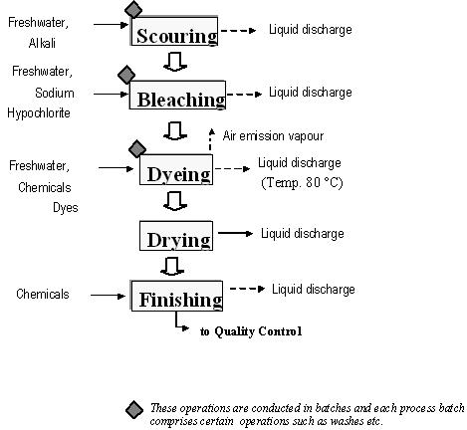

A Dyeing process is the interaction between a dye and a fibre, as well as the movement of dye into the internal part of the fibre. Generally, a dyeing process involves adsorption (transfer of dyes from the aqueous solution onto the fibre surface) and diffusion (dyes diffused into the fibre). In addition to direct absorption, dyeing may also involve the precipitation of dyes inside the fibre (vat dyes), or chemical reaction with the fibre (reactive dyes).

The effects are listed

1. Results in [waste of vital freshwater](https://www.fashionrevolution.org/the-true-cost-of-colour-the-impact-of-textile-dyes-on-water-systems/).
2. Unusable, chemical-polluted toxic wastewater is released into water bodies.
3. Dangerous heavy metals are also used in synthetic dyes & dyeing processes which make their way into the water bodies. For example, cadmium, lead and copper, which are found in dyes and pigments in clothing, accumulate in our bodies and can damage organs and our central nervous system.
4. Dyes increase the temperature & pH of water.
5. The [oxygen content of the water is greatly reduced,](https://www.scirp.org/html/4-8301582_17027.htm) leading to the death of fish and other aquatic biodiversity.
6. Different kinds of bacteria, viruses, and harmful fungi can grow freely in this polluted water. Corrosive chemicals cause damage to metal and drainpipes.

**Properties of Dyes**

There are various types of characteristics of dyes. The followings are the major properties of dyes. They are-

1. Firstly, dyes can be water-soluble or water-insoluble.
2. Secondly, some dyes are anionic, some are cationic and some have both anionic and cationic properties.
3. Thirdly, some dyes need low temperatures and pressure to make a solution, some need high temperatures and pressure to make a solution.
4. After that, dyes must have suitable colors.
5. Thereafter, it should not affect by the light.
6. Dyes must be fixed with the fabric directly or with the help of a mordant.
7. Lastly, all of the properties of dyes depend on the molecular structure of dyes.

**Vision:**

We see ourselves spreading all the colours of the palette to make this world a bit more beautiful.

You might have been told that dye chemical suppliers do not care about the environment, but that’s not the case with us. Our formulations are easy on the environment and we can see ourselves making them more natural and beautiful in the coming years.

We see ourselves making it easy for the customers to get the most beautiful and rare shades without any hassle. In a world turning ultra-modern without caring about nature, we see ourselves offering chemicals that are easy to handle and leave no adverse effects on nature.

**Mission:**

Our mission is to be a global auxiliaries manufacturing company. We are working with a goal to make the dye process safe, secure and environment friendly.

Our sole motive is to achieve customer satisfaction with our services. On the path of becoming the best dye manufacturer, we wish to achieve our goals with a smile on your face.

After gaining so much love from our customers as the best global dye chemicals manufacturer, we look forward to being the best on a global level as well.

**CHAPTER-II**

**PROJECT DESIGN**

**2.1 NEED FOR THE STUDY**

Employee satisfication plays vital role in the organization success. High satisfication leads to success and low satisfication brings to defeat in its wake. The play of satisfication is no less important for an industrial undertaking. The success of failure of the industry much depends up on the satisfication of its employees.

The main focus of this study is to measure the employee satisfactions and quality of life at Muthu Dyers Erode, Tamil Nādu. This project emphasizes the importance of quality of life and work satisfactions among employee in dye industry.

## 2.2 OBJECTIVES OF THE STUDY

* To determine the level of satisfaction of the respondent regarding their job.
* To identify the various factors that influences employee satisfaction.
* To find out employee engagement level in the organization.
* To offer suggestions to the management to improve their employee’s satisfactory level.

### To analyse the satisfaction level of workers in dye production firm with various aspects of their work environment.

### To analyse relationships between various demographic factors..(gender, salary, experience, age) of workers with perceived Quality of Work Life..

### To investigate the satisfaction of workers about the existing and expected Quality of Work Life in the dye industry.

### To identify the significant gap between the existing and expected Quality of Work Life.

### To identify the impact of work-related factors and to see the impact of demographic variables on the existing Quality of Work Life of workers in the dye industries

### To identify the factors affecting quality of work life. ▪

### To analyze the measures adopted by the organization to improve the qualit of work life among workers.

### To suggest suitable measures to improve the quality of work life among workers.

* To study the need and importance of quality of work life of employees.
* To measure the quality of work life practices applied in the women employees in dye sector in Kerala.
* To examine the satisfaction level of women employees towards quality of work life in selected dye companies in Kerala.

## 2.3 SCOPE OF THE STUDY

Work is an integral part of our everyday life, be it our livelihood or career or business. On an average we spend around twelve hours daily in the work place, that is one third of our entire life; it does influence the overall quality of our life. It should yield job satisfaction, give peace of mind, a fulfillment of having done a task, as it is expected, without any flaw and having spent the time fruitfully, constructively and purposefully. Even if it is a small step towards our lifetime goal, at the end of the day it gives satisfaction and eagerness to look forward for the next day. A happy and a healthy employee will give better turnover, make good decisions and positively contribute to the organizational goal. An assured good quality of work life will not only attract young and new talent but also retain the existing experienced talent. This being the virtual fact, the current study on Quality of Work Life among workers with special reference to dye industry in Erode district – A dye hub, is expected to prove extremely useful for the organization to improve the quality of work life among its workers with the help of the recommendations given by the investigator.

The present study makes an attempt to assess and analyses the level of job satisfaction among the employees of Erode industry. The study identities the important factors that influence the job satisfaction of the employees such as personal details. Job related details, work environment, welfare measures, organizational policies and overall job satisfaction. The study is based on 100 employees drawn from the Erode organizations. The study would help the management to understand.the level of job satisfaction, and identify the areas of satisfaction and dissatisfaction existing in the organization. The study is important because job satisfaction survey is a procedure by which employees collectively report their feeling about their jobs. It is used as a diagnostic instrument for assessing employee problems and exchange management to take necessary steps to solve it.

## 2.4 LIMITATIONS OF THE STUDY

* The study is limited to the workers of dye industry in Erode district and therefore the
* findings of the study cannot be extended to other areas.
* Convenient sampling has been used in the study and it has its own limitations.
* Personal bias of the respondents might have crept in while answering a few questions in the structured interview schedule.
* Results of the study may not be generalized.
* Any study having a bearing on attitude, incomplete, false data and non responses to some questions could not be avoided; however, in any case, the researcher took most extreme efforts to limit such mistakes.
* The quality of work life is a subject including number of exercises; the most widely familiar practices only were considered in this study.
* The results of the investigation are limited to dye companies in Kottayam district. It is not pertinent for the comparable association in different districts and states.

## 2.5 REVIEW OF LITERATURE

#### INTRODUCTION :

Employee satisfaction continues to be among top priorities of Global Corporations. Engaged employees do better jobs and are essential to the organizations’ long-term success. Winning loyalty and commitment of employees is a critical responsibility and a key to organizations’ strategic objectives.

Employee satisfaction represents the constellations of person’s attitude towards or about the job. In general, employee satisfaction is the attitude towards the job as a whole. Employee satisfaction is a function of satisfaction with different aspects of job, that is supervision, pay, works itself, co-workers, promotion, etc., and the level of importance one attaches to these respective components. Job satisfaction is a multifaceted construct Churchill, Ford, and Walker (1974);

Comer, Machleit, and Lagace (1989); Lagace, Goolsby, and Gassenheimer (1993).

The most commonly used facets of satisfaction Judge, Thoreson, Bono, and Patton (2001) are satisfaction with pay, promotion opportunities, coworkers, supervision, and the work itself Smith, Kendall, and Hulin (1969). These five job facets usually account for a substantial amount of the variance in overall job satisfaction Kinicki, McKee-Ryan, Schriesheim, and Carson (2002). There have been many more researches to identify other important and contemporary facets of job satisfaction. Taber and Alliger (1995) suggested that to understand overall job attitudes, researchers must identify the principal tasks and activities in which employees engage. Brief (1998) studied how the changing nature of work leads to facets, considered most important to job satisfaction are still indeed most important and if new facets or facets once considered peripheral to job satisfaction have become more central. Judge et al. (2001) argued that the breadth of job characteristics must include all elements that may have become more salient in contemporary job settings. Similarly, Rogelberg, Leach, Warr, and Burnfield (2006) argued that to understand components of overall job

attitudes, the principal tasks/activities in which employees are required to spend large amounts of time should be considered.

**Sashikanta Khuntia and Subhodip Adhikary** states job satisfaction is the extent to which one feels good about the job. Major constituents of the job satisfaction are salary, promotion policies, career development, work pressure, co-worker, and supervision, leave facilities, perform appraisal, job security. ANOVA and Regression Analysis is used in the research. Author concluded by stating that Job satisfaction of the employees affected by the work pressure, salary package and job security. It also observed that the employees have the fear

of losing jobs.

**SSM Sadrul Huda, Nargis Akhtar and Afsana Akhtar (2011)** have made an attempt to find out the correlation between work motivation and job satisfaction in Bangladesh. 200 sample units Garment workers were selected and it has been concluded that the workers are unhappy with their working environment and about pay package. Out of eight variables, only three variable workers of the garment industry in Bangladesh have satisfaction.

**M. M. C. De Silva (2014)** studied on employee satisfaction and the main objective of the study was to examine the impact of job satisfaction and employee education on dye industry with reference to the Gampaha district, Sri Lanka. 90 respondents (machine operators) were selected for the survey. It has been found that there was no positive relationship between employee efficiency, job satisfaction and education and management should improve its strategies.

**Dr.Rajenmehrotra** the article, ‘job satisfaction and attitude of managers in co-operatives in Kerala, conclude that, ‘the concept of job satisfaction is a comprehensive one coveting attitudes of an employee towards various job factors. It is an attitude which results from a balancing summation of may specific likes and dislikes experienced in connection with the job. Thus job satisfaction is the attitude of an employee resultant on a favourable relationship between his perception of how well his job can fulfil his various needs and his expectations or aspirations, and the extent to which these needs are actually fulfilled.

**Sathya** the article, ‘A study on Measuring of Morals among workers says that, ‘High morale will have a favourable impact on the organizations growth prospect. High moral will exist when people have favourable attitudes towards their top management, superiors and pears, their job, management policies, and practices and their company as a whole. Low morale has its own negative effect on productivity, performance and it also leads to absenteeism, turnover and strikes. The dimensions that had direct impact on morale and their results are, status among relatives and friends, training, willingness to spend time, individual adjustment, working condition, stress relaxation, nature of work, health condition, safety welfare etc’.

**Baba and Jamal (1991**) listed what they described as typical indicators of quality of working life,

including: job satisfaction, job involvement, work role ambiguity, work role conflict, work role

overload, job stress, organizational commitment and turn-over intentions.

**Bertrand and Scott (1992)** in their study ―Designing Quality into Work Life‖ found that

improvements in the quality of work life are achieved not only through external or structural

modifications, but more importantly through improved relations between supervisors and

subordinates.

**Datta (1999)** in his study ―Quality of Work Life: A Human Values Approach‖ say that in a

deeper sense, quality of work life refers to the quality of life of individuals in their working

organizations—commercial, educational, cultural, religious, philanthropic or whatever they are.

Modern society is organizational society. Individuals spend much of their lives in organizations.

Hence, the importance of quality of work life is unquestionable.

**Normala and Daud (2010)** in their study ―Investigating the Relationship between Quality of

Work Life and Organizational Commitment Amongst Employees in Malaysian Firms‖ say that

the quality of work life of employees is an important consideration for employers interested in

improving employees‘ job satisfaction and commitment.

**Jonnalagadda Vanaja and Yvvsss Vara Prasad (2018),** Stated the “Quality of work life balance in a dye shop “, work life dimensions of economic benefits, marital status and general life satisfaction.

**Indumathy and Kamalraj (2012) ,** Concluded the level of happiness or dissatisfaction with one’s career. The peoples are asset in the organization rather than costs, it will be consider as a quality of work life of employees. Today’s workforce is realizing the importance of balance between carrer and personal lives.

**Yogesh Jain and Renil Thomas (2016)**, Defined that major conceptual area of work life balance are necessary in the recent era. Several experiments indicate that the interest in improving the QWL reflects social changes.

**2.6 RESEARCH METHODOLOGY**

The methodology this study consists of primary data. These data is collected from the respondents through questionnaires. The primary data were collected from the respondent. Problem definition is the first step towards any research project. The problem in this project report was the

attrition rate of organization seems to be increasing day by day; hence affecting the overall growth of the organization. The research design used in this study is exploratory research

design.

The research design chosen is descriptive in nature. The universe of the study refers to the

workers of the selected 5 dye industry related organizations in Erode district – A dye hub.

The total strength of the universe is 600.The sample size taken to conduct the research is 60

workers.10% of the universe has been taken for the research.Structured interview schedule was used for primary data collection. Secondary data was collected from earlier research work, various published journals, magazines, websites and online articles. Simple Percentage Analysis, Chi – Square Analysis and Weighted Average Score Analysis are the tools used for data analysis.

**DATA AND SOURCES OF DATA**

For this study primary data collection method is used. Interview Schedule Method is used to collect the information from the respondents. The secondary data has been used to get information about the company profile and industry profile through websites.

**STATISTICAL TOOL**

The tools used in this research for analysis is Descriptive Statistics, T-Test and ANOVA.

Percentage analysis is used to describe the personal characteristics of garment employees and chi- square is used for analyzing their relationship between the demographic profile and work-life, problems and challenges faced by working women in dye industry.

**DESCRIPTIVE STASTISTICS**

Percentage analysis is a simple statistical instrument which is widely used in analysis and interpretation of primary data. It deals with the number of respondents reply to the questionnaire in percentage attained from the total population of the study. It is one of the simple form of analysis which helps the researcher to realize the outcome of the study. It is normally used for inferring the results in quantitative terms. In this study, percentage analysis was used to measure the percentage of demographic profile.

**T-Test**

The Independent Sample t test compares the means of two independent groups in order to determine whether there is statistical evidence that is associated population means are significantly different.

The t-test formula is applied to the sample population. The t-test formula depends on the [mean](https://www.cuemath.com/data/arithmetic-mean/), [variance,](https://www.cuemath.com/data/variance-and-standard-deviation/)and [standard deviation](https://www.cuemath.com/data/variance-and-standard-deviation/) of the data being compared. There are 3 types of t-tests that could be performed on the n number of samples collected.

* One-sample test,
* Independent sample t-test and
* Paired samples t-test

The critical value is obtained from the t-table looking for the degree of freedom(df = n-1) and the corresponding α value(usually 0.05 or 0.1). If the t-test obtained statistically > CV then the initial hypothesis is wrong and we conclude that the results are significantly different.

**ONE SAMPLE TEST**

For comparing the mean of a population  from n samples, with a specified theoretical mean μ, we use a one-sample t-test.

where σ/√n is the standard error

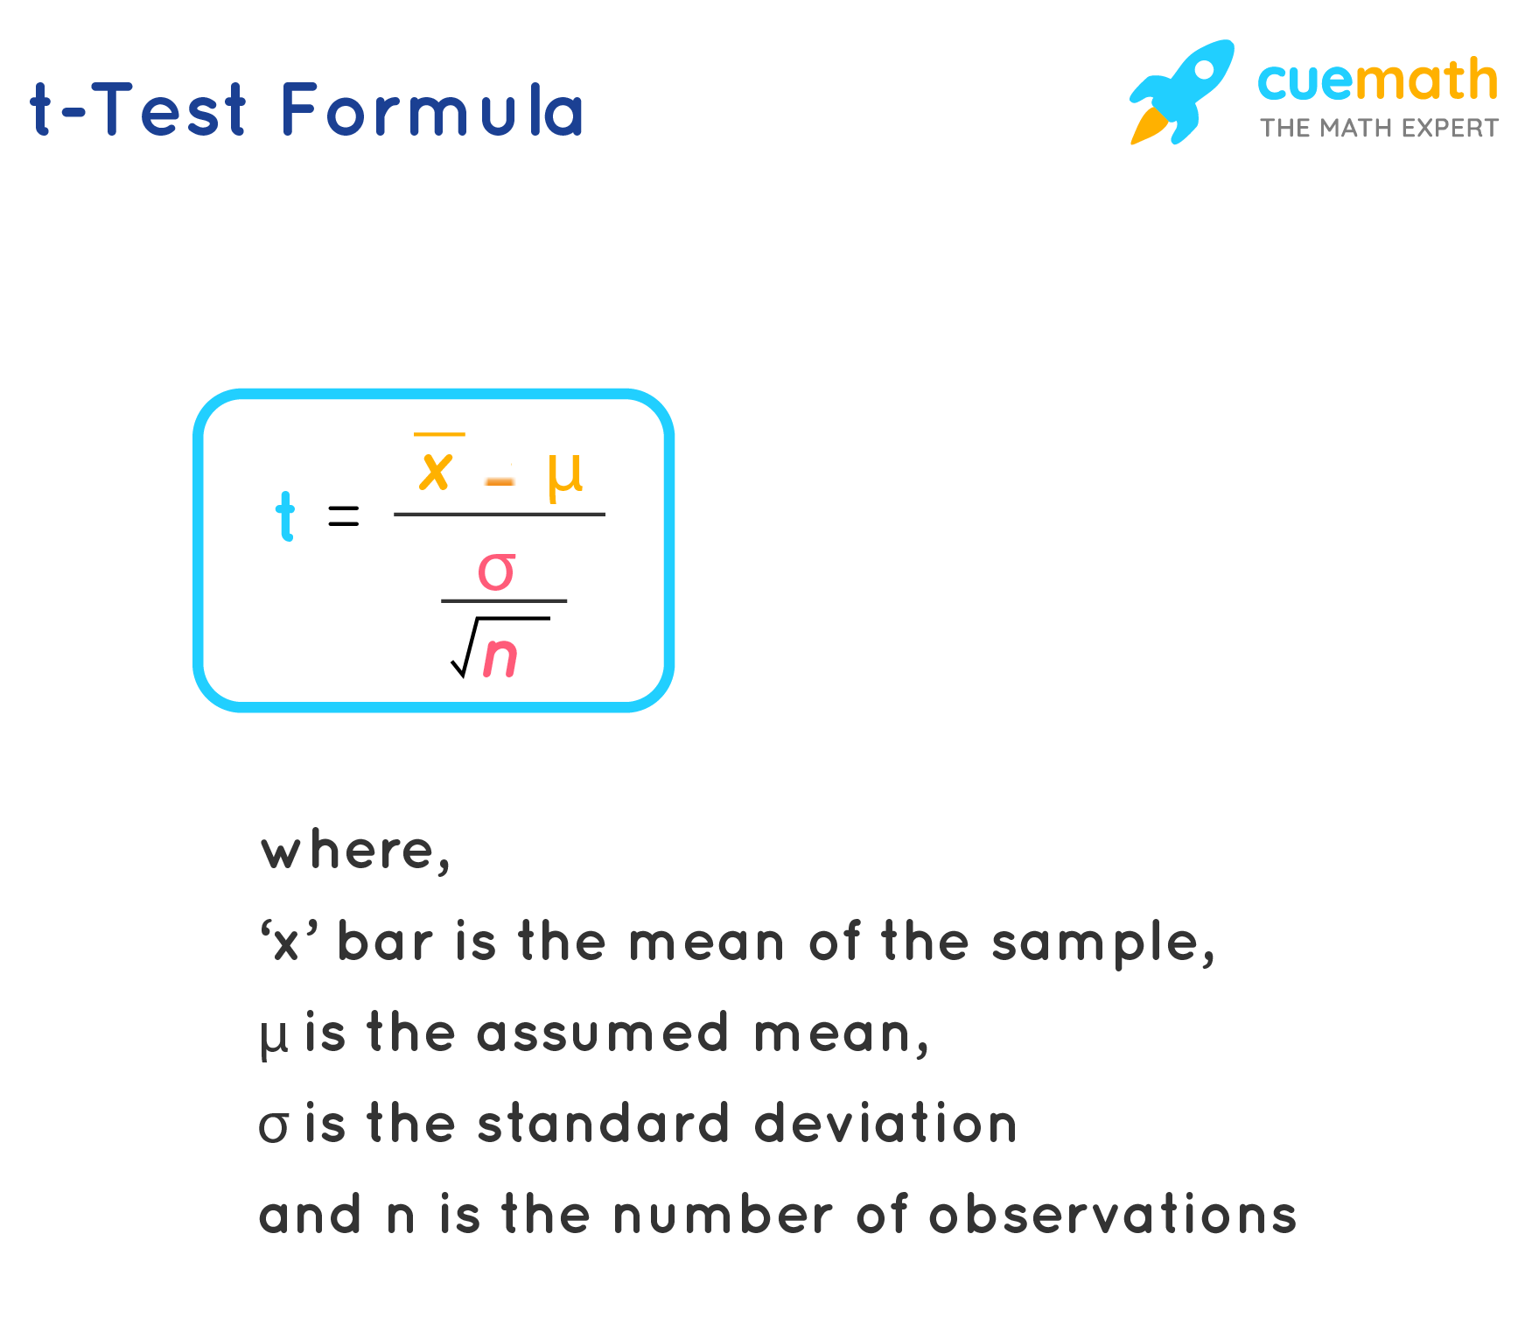

### 

### **INDEPENDENT SAMPLE T-TEST**

Students t-test is used to compare the mean of two groups of samples. It helps evaluate if the means of the two sets of data are statistically significantly different from each other.

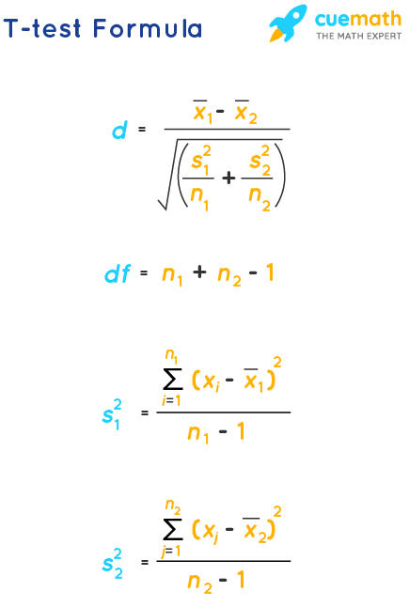

where

* t = Student's t-test
* x1 = mean of first group
* x2= mean of second group
* s1 = standard deviation of group 1
* s2 = standard deviation of group 1
* n1= number of observations in group 1
* n2= number of observations in group 2

### **PAIRED SAMPLE T-TEST**

Whenever two distributions of the variables are highly correlated, they could be pre and post test results from the same people. In such cases, we use the paired samples t-test.

where

* t = Student's t-test
* x1−x2 = Difference mean of the pairs
* s= standard deviation
* n = sample size

**ANOVA**

Analysis of variance is a collection of statistical models and their associated estimation procedures used to analyze the differences among group means in a sample. The one – way analysis of variance is used to determine whether there are any statistically significant differences between the means of three or more independent groups.

**DEMOGRAPHIC PROFILE**

|  |  |  |  |
| --- | --- | --- | --- |
| **S.No** | **Variables** | **Classes** | **Percentage** |
| 1. | Age | Below 25 years  26-35 years  36-40 years  Above 40 years | 14.0  66.0  14.0  06.0 |
| 2. | Gender | Male  Female | 80.0  20.0 |
| 3. | Marital Status | Married  Unmarried | 38.0  62.0 |
| 4. | Nature of Work | Permanent  Temporary | 56.0  44.0 |

**CHI-SQUARE TEST**

|  |  |  |  |
| --- | --- | --- | --- |
| **PARTICULARS** | **VALUE** | **DF** | **ASYMP.SIG** |
| Pearson Chi-Square  Likelihood Ratio  Linear-by-Linear Association  N of Valid Cases | 1.682E2a  133.445  69.692  100 | 9  9  1 | .000  .000  .000 |

10 cells (62.5%) have expected count less than 5. The minimum expected count is .60.

From the chi square analysis at 5% significant level of calculated value is .000 it’s less than table value so the alternative hypothesis is (Ha) is accepted. We concluded that there is significant relationship between age and relationship between co-workers.

**AGE AND LEVEL OF SATISFACTION**

In order to find the relationship between various factors and level of job satisfaction, chi-square test was used and the result of the test is shown below.

**NULL HYPOTHIESIS (Ho)**

There is no significant relationship between age and co-workers relationship.

**ALTERNATIVE HYPOTHIESIS (Ha)**

There is significant relationship between age and co-workers relationship.

**Age of the respondents * co-worker relations Cross tabulation**

|  |  |  |  |  |  |
| --- | --- | --- | --- | --- | --- |
| **Particulars** | **very good** | **good** | **moderate** | **poor** | **Total** |
| Age of the respondents  below  25 years  26-35  years  36-40  years  above  40  years  Total | 14  2  0  0  16 | 0  42  0  0  42 | 0  22  10  0    32 | 0  0  4  6  10 | 14  66  14  6  100 |

**DATA COLLECTION AND SAMPLE SIZE**

The data was collected by distributing the questionnaires to the employees. The sampling frame is the pool from which the interviewees are chosen. All the items consideration in any field of inquiry constitutes a universe of population. In this research only a few items can be selected form the population for our study purpose. The items selected constitute what is technically called a sample. Here our sample size is 80 employees from the total population of the employees. The samples are selected on the basis of simple random sampling technique

**CORRELATION**

The correlation is one of the most common and most useful statistics. A correlation is a single number that describes the degree of relationship between two variables. For example, there is a correlation between income and education. We find that people with higher income have more years of education. (You can also phrase it that people with more years of education have higher income.) When we know there is a correlation between two variables, we can make a prediction. If we know a group’s income, we can predict their years of education.

**CHAPTER-III**

**DATA ANALYSIS AND INTERPRETATION**

### **3.1.PERCENTAGE ANALYSIS**

Table No: 3.1.1

Age wise – Distribution of The Respondents

|  |  |  |  |
| --- | --- | --- | --- |
| **S.NO** | **AGE** | **NO.OFRESPONDENTS** | **PERCENTAGE** |
| 1. | 20-25 | 44 | 33.1 |
| 2. | 25-30 | 64 | 48.1 |
| 3. | 30-35 | 25 | 18.8 |
| 4. | 35-40 | 0 | 0 |
| TOTAL |  | 133 | 100.00 |

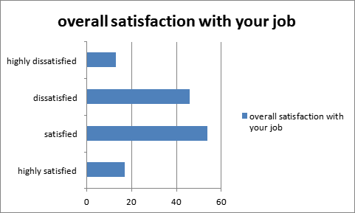

### Figure No: 3.1.1 Age wise – Distribution of Respondents

INTERPRETION:

It is interpreted that 33.1% of the respondents are between 20-25 years old, 48.1% of them are between 25-30, 18.8% respondent are 30-35, years old.

INFERENCE:

Majority (48.1 %) of the respondents are age between 25 to 30 years.

Table No: 3.1.2

Gender of the respondents

|  |  |  |  |
| --- | --- | --- | --- |
| **S NO** | **GENDER** | **NO.OF.RESPONDENTS** | **PERCENTAGE** |
| 1. | Male | 80 | 60.2 |
| 2. | Female | 53 | 39.8 |
| TOTAL |  | 133 | 100.00 |

INTERPRETION:

From the above table it is interpreted that the number of male respondent is 60.2% and female respondent is 39.8%.

INFERENCE:

Majority (60.2%) of the respondents are male.

INTERPRETION:

It is interpreted that 6.8% respondent is Diploma, 57.9% respondent is UG, 35.3% respondent is PG.

INFERENCE:

Majority (57.9%) of the respondents are UG.

Table No:3.1.3

Education Qualification

|  |  |  |  |
| --- | --- | --- | --- |
| **S.NO** | **PARTICULARS** | **NO.OF.RESPONDENTS** | **PERCENTAGE** |
| 1. | Diploma | 9 | 6.8 |
| 2. | UG | 77 | 57.9 |
| 3. | PG | 47 | 35.3 |
| 4. | Others | 0 | 0 |
| TOTAL |  | 133 | 100 |

Table No: 3.1.4

Working in the organization

|  |  |  |
| --- | --- | --- |
| **PARTICULARS** | **NO.OF.RESPONDENTS** | **%** |
| 5-10years | 33 | 24.8 |
| 10-15years | 56 | 42.1 |
| 15-20years | 44 | 33.1 |
| More than 20y | 0 | 0 |
| Total | 133 | 100.00 |

INTERPRETION:

From the above table it is interpreted that 24.8% respondent is 5-10years , 42.1% respondent is 10- 15 years, 33.1% respondent is 15-20 years, no respondent of more than 20years.

INFERENCE :

Majority(42.1%)of respondent are 10-15years.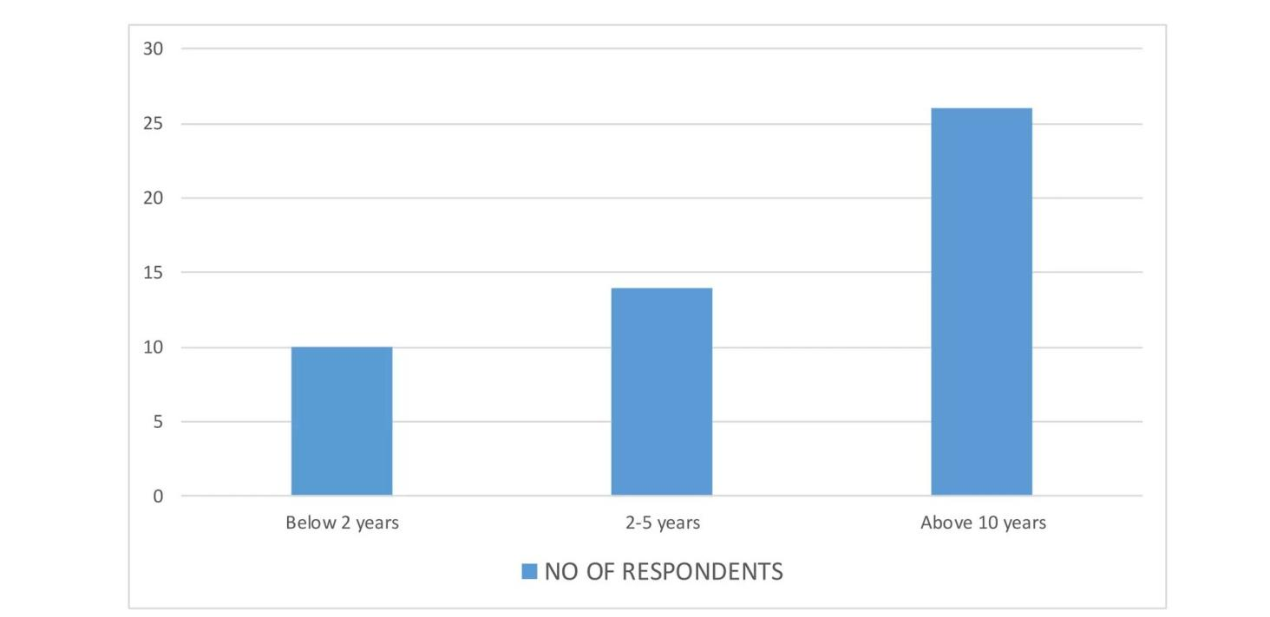

Figure No: 3.1. 2 Employee Experience wise Respondents

Table No: 3.1.5

Working environmental of the organization

|  |  |  |
| --- | --- | --- |
| **PARTICULARS** | **NO.OF.RESPONDENTS** | **PERCENTAGE** |
| Highly satisfied | 24 | 18.0 |
| satisfied | 52 | 39.1 |
| Highly dissatisfied | 42 | 31.6 |
| dissatisfied | 14 | 10.5 |
| No opinion | 1 | 0.8 |
| Total | 133 | 100.00 |

INTERPRETATION:

From the above table, it is interpreted that 18.0% respondent are highly satisfied, 39.1% respondent are satisfied, 31.6% respondent are highly dissatisfied, 10.5% respondent are dissatisfied.

INFERENCE :

Majority (39.1%) of respondent are satisfied.

Table No :3.1.6

The relationship of management towards to employee?

|  |  |  |
| --- | --- | --- |
| **OPTIONS** | **NO.OF.RESPONDENTS** | **%** |
| EXCELLENT | 31 | 23.3 |
| GOOD | 65 | 48.9 |
| AVERAGE | 30 | 22.6 |
| POOR | 6 | 4.5 |
| VERY POOR | 1 | 0.8 |
| TOTAL | 133 | 100.00 |

INTERPRETATION :

It is interpreted that 23.3% respondent are excellent, 48.9% respondent are good, 22.6% respondent are average, 4.5% respondent are poor, 0.8% respondent are very poor.

INFERENCE:

Majority (48.9%) respondent are good.

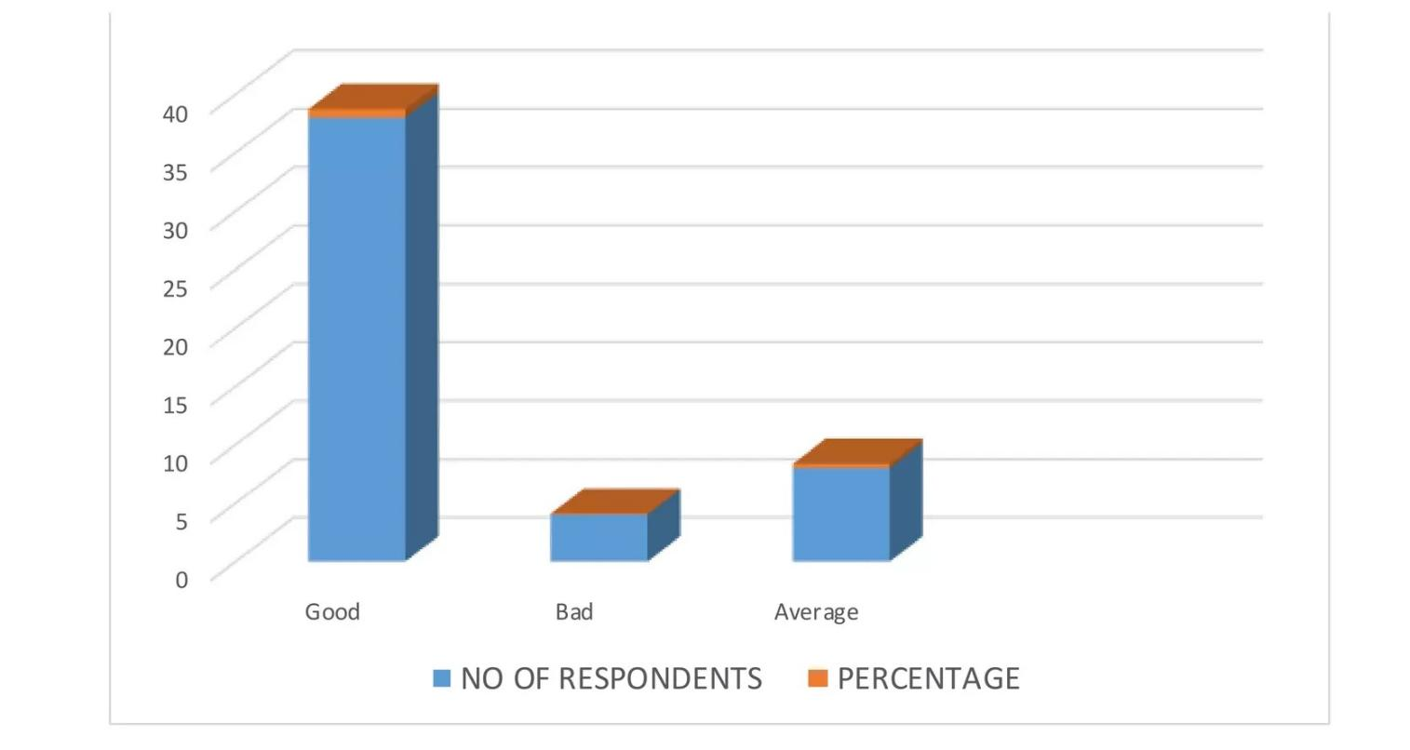

Figure No: 3.1.3 Relation ship management towards employee

Table No: 3.1.7

Payment policy of the company.

|  |  |  |  |
| --- | --- | --- | --- |
| **S.NO** | **PARTICULARS** | **NO.OF.RESPONDENTS** | **%** |
| 1. | Highly satisfied | 35 | 26.3 |
| 2. | satisfied | 54 | 40.6 |
| 3. | dissatisfied | 33 | 24.8 |
| 4. | Highly dissatisfied | 11 | 8.3 |
| 5. | No opinion | 0 | 0 |
| 6. | total | 133 | 100.00 |

INTERPRETATION:

From the above table, it is interpreted that 26.3%respondent are highly satisfied, 40.6% respondent are satisfied, 24.8% respondent are dissatisfied, 8.3%respondent are highly dissatisfied, there is no respondent from no opinion.

INFERENCE:

Majority(40.6%) of the respondent are satisfied.

TABLE 3.1.8.

Opportunity to work in the interested project?

|  |  |  |
| --- | --- | --- |
| **PARTICULARS** | **NO.OF.RESPONDENTS** | **%** |
| Strongly agree | 28 | 21.1% |
| agree | 59 | 44.4% |
| neutral | 37 | 27.8% |
| disagree | 3 | 2.3% |
| Strongly disagree | 6 | 4.5% |
| Total | 133 | 100.00 |

INTERPRETATION:

From the above table 21.1% respondent are strongly agree, 44.4% respondent are agree, 27.8% respondent are neutral, 2.3% respondent are disagree, 4.5% respondent are strongly disagree.

INFERENCE:

Majority(44.4%)respondent are agree.

Table No: 3.1.9

Training program of the organization

|  |  |  |
| --- | --- | --- |
| **PARTICULARS** | **NO.OF.RESPONDENTS** | **%** |
| excellent | 29 | 21.8 |
| good | 46 | 34.6 |
| average | 50 | 37.6 |
| poor | 7 | 5.3 |
| Very poor | 1 | 0.8 |
| Total | 133 | 100.00 |

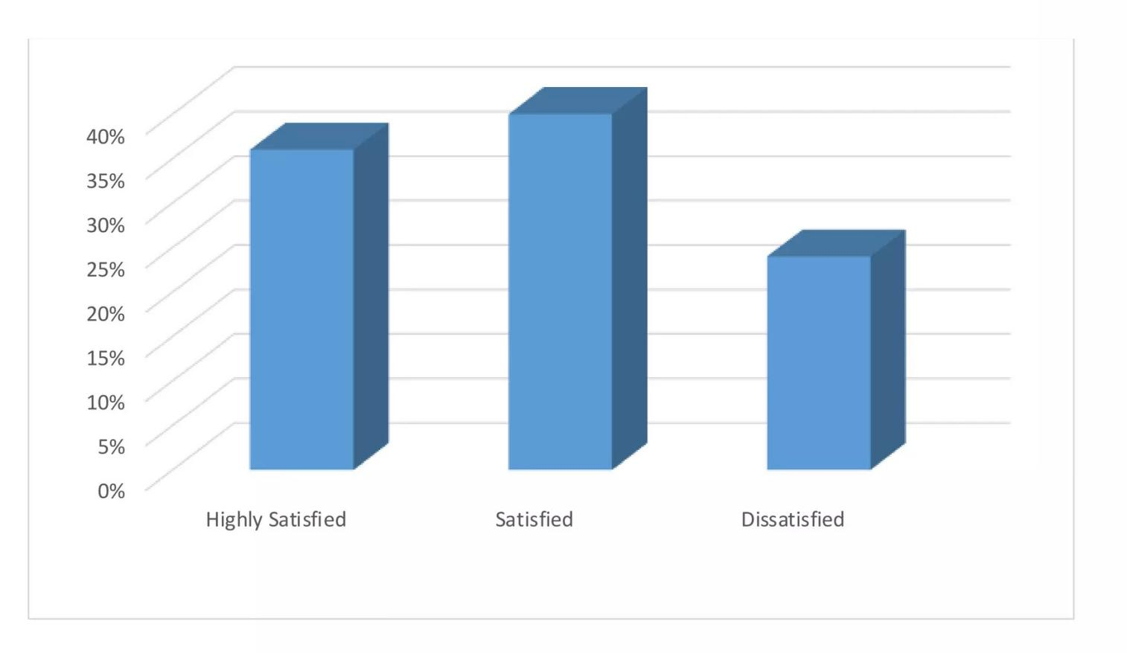

Figure No: 3.1.4 Employee Training programme satisfication

INTERPRETATION:

From the above table that 21.8% respondent are excellent, 34.6% respondent are good, 37.6% respondent are average, 5.3% respondent are poor, 0.8% respondent are very poor.

INFERENCE :

Majority (37.6%) respondent are average.

Table No: 3.1.10

Influence decision that affect you

|  |  |  |
| --- | --- | --- |
| **PARTICULARS** | **NO.OF.RESPODENTS** | **%** |
| Strongly agree | 29 | 21.8 |
| agree | 53 | 39.8 |
| neutral | 43 | 32.3 |
| disagree | 7 | 5.3 |
| Strongly disagree | 1 | 0.8 |
| Total | 133 | 100.00 |

INTERPRETATION:

From the above table that 21.8% respondent are strongly agree, 39.8% respondent are agree 32.3% respondent are neutral, 5.3% respondent are disagree, 0,8% respondent are strongly disagree.

INFERENCE:

Majority (39.8%) respondent are agree.

Table No: 3.1.11

Equal Treatment

|  |  |  |
| --- | --- | --- |
| **PARTICULARS** | **NO.OF.RESPODENTS** | **%** |
| Strongly agree | 17 | 12.8% |
| agree | 55 | 41.4% |
| neutral | 45 | 33.8% |
| disagree | 13 | 9.8% |
| Strongly disagree | 3 | 2.3% |
| Total | 133 | 100.00 |

INTERPRETATION:

From the above table that 12.8% respondent are strongly agree, 41.4% respondent are agree, 33.8% respondent are neutral, 9.8% respondent are disagree, 2.3% respondent are strongly disagree.

INFERENCE:

Majority (41.4%) respondent are agree.

Table No: 3.1.12

Infrastructure facilities provided by the organization

|  |  |  |
| --- | --- | --- |
| **PARTICULARS** | **NO.OF.RESPONDENTS** | **%** |
| Highly satisfied | 23 | 17.3 |
| satisfied | 62 | 46.6 |
| Highly dissatisfied | 36 | 27.1 |
| dissatisfied | 10 | 7.5 |
| No opinion | 2 | 1.5 |
| Total | 133 | 100.00 |

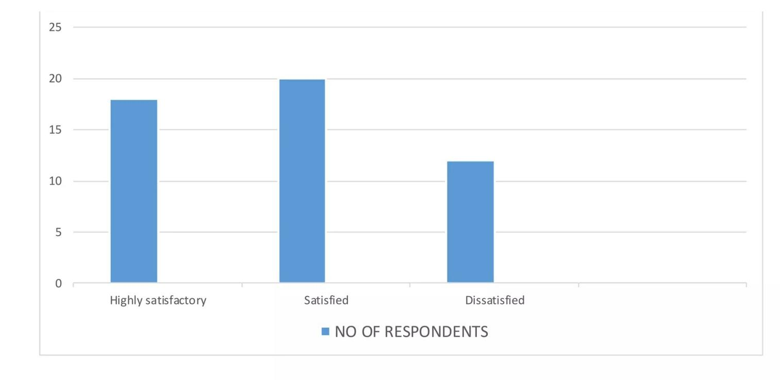

Figure No: 3.1.5 Employee facilities provided by organization

INTERPRETATION:

From the above table that 17.3% respondent are highly satisfied, 46.6% respondent are satisfied, 27.1% respondent are highly dissatisfied, 7.5% respondent are dissatisfied, 1.5% respondent are no opinion.

INFERENCE:

Majority (46.6%) respondent are satisfied.

INTERPRETATION:

The table is 19.5% respondent are strongly agree, 42.1% respondent are agree, 25.6% respondent are neutral, 12.0% respondent are disagree, 0.8% respondent are strongly disagree.

INFERENCE:

Majority (42.1%) respondent are agree.

Table No:3.1.13

Safety of employees

|  |  |  |
| --- | --- | --- |
| **PARTICULARS** | **NO.OF.RESPONDENT** | **%** |
| Strongly agree | 26 | 19.5 |
| agree | 56 | 42.1 |
| neutral | 34 | 25.6 |
| disagree | 16 | 12.0 |
| Strongly disagree | 1 | 0.8 |
| Total | 133 | 100.00 |

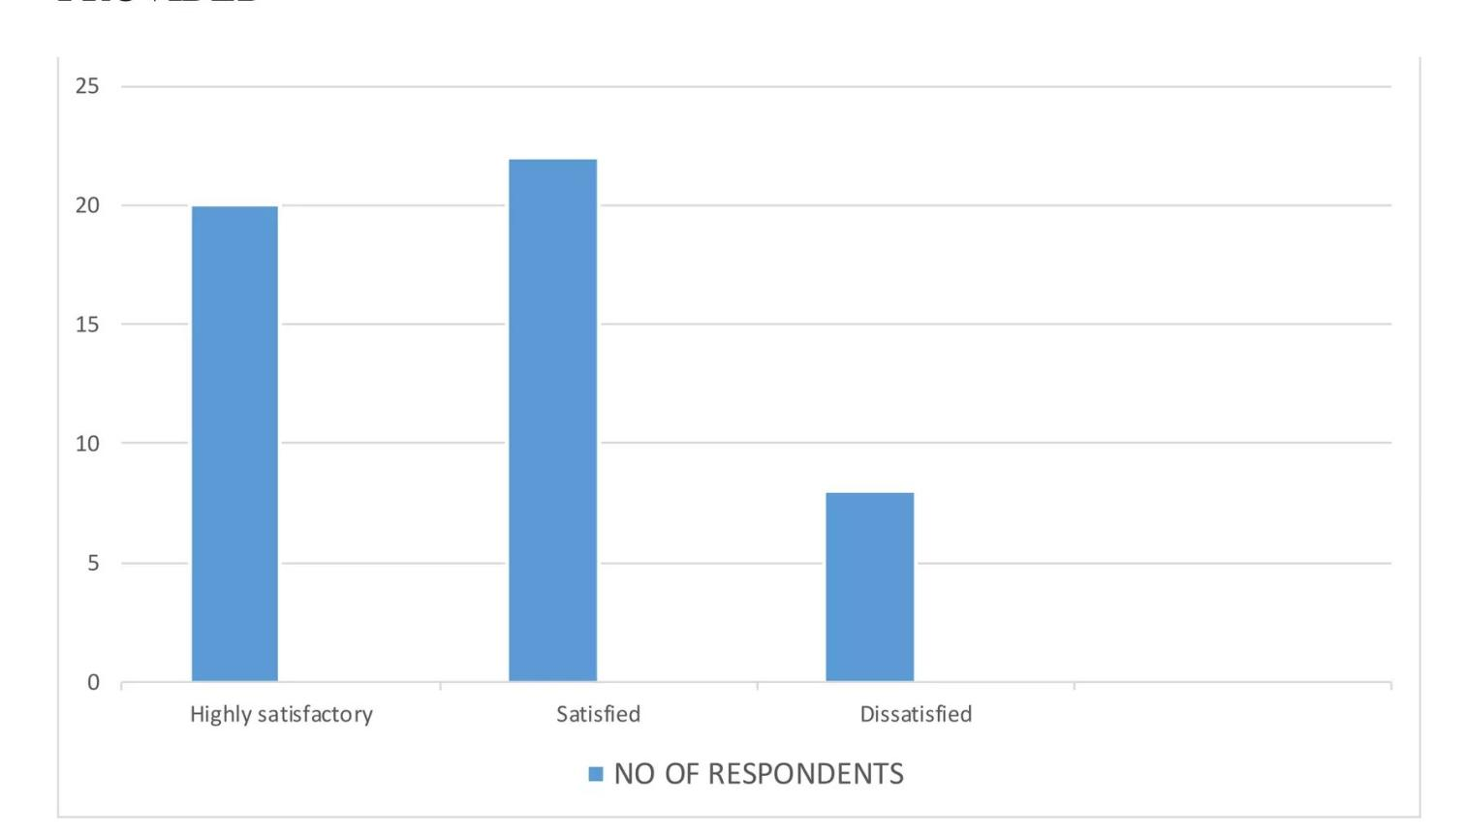

Figure No: 3.1.6 Safety of employee

Table No : 3.1.14

Overall satisfaction with your job

|  |  |  |
| --- | --- | --- |
| **PARTICULAR** | **NO.OF.RESPODENTS** | **%** |
| Highly satisfied | 17 | 12.8 |
| satisfied | 54 | 40.6 |
| dissatisfied | 46 | 34.6 |
| Highly dissatisfied | 13 | 9.8 |
| No opinion | 3 | 2.3 |
| Total | 133 | 100 |

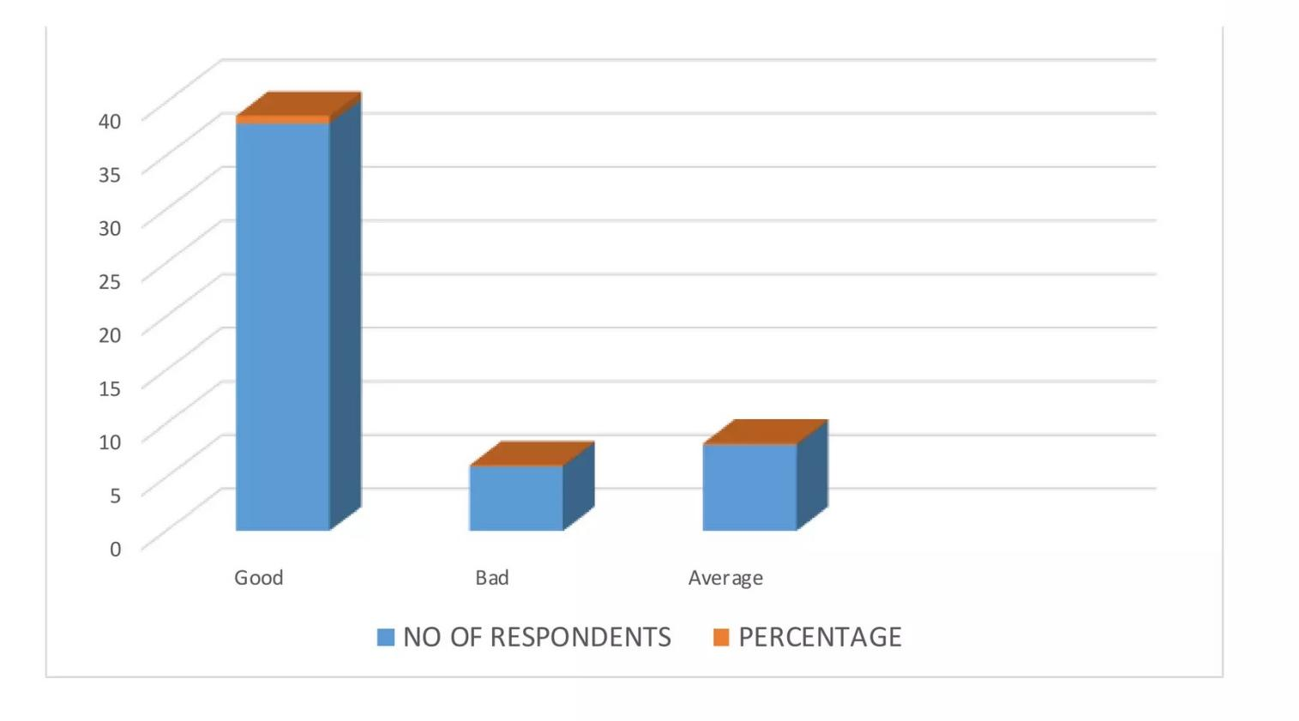

Figure No: 3.1.7 Satisfactions level of employee

INTERPRETATION:

From the above table that 12.8% respondent are highly satisfied, 40.6% respondent are satisfied, 34.6% respondent are dissatisfied, 9.8% respondent are highly dissatisfied, 2.3% respondent are no opinion.

INFERENCE:

Majority (40.6%) respondent are satisfied.

**HYPOTHESIS TESTING and cm-SQUARE TEST**

HO : There is no significant relationship between employees' satisfaction in work facilities and working relationship with supervisor.

HI : There is significant relationship between employees' satisfaction m work facilities and working relationship with supervisor.

**OBSERVED FREQUENCIES**

|  |  |  |  |  |
| --- | --- | --- | --- | --- |
| **OBSERVED FREQUENCY** | **HIGHLY SATISFIED** | **SATISFIED** | **DISATISFIED** | **TOTAL** |
| Employees work facilities | 18 | 20 | 12 | 50 |
| Employees work  relationshipwith supervisor | 10 | 38 | 2 | 50 |
| Total | 28 | 58 | 14 | 100 |

|  |  |  |  |  |
| --- | --- | --- | --- | --- |
| 0 | E | 0-E | (O-E)2 | (O-E)2/E |
| 18 | 50*28/l 00= 14 | 4 | 16 | 1.142 |
| 20 | 50*58/100=29 | -9 | 81 | 2.793 |
| 12 | 50*44/l 00=7 | 5 | 25 | 3.571 |
| 10 | 50*28/ l00= 14 | -4 | 16 | 1.142 |
| 40 | 50*58?Z9=29 | 11 | 121 | 4.172 |

**CHI-SQUARE = (0-E) 2/E**

**I(0-E) 2/E = 12.82**

**Degree of Freedom= (c-1) (r-1) 5% level of significance= 2 Table value = 5.991**

**0= Observed Frequency E= Expected Frequency**

**Expected Frequency= Row TotaVColumn Total * Grand Total**

**COMMENT**

As the calculated value is more than table value. Therefore null hypothesis is rejected and it concluded that there is significant relationship between employees' satisfaction in work facilities and working relationship with supervisor.

**3.2 CHI-SQURE ANALYSIS**

Table showing the association between age of the employees and opinion about the training program of the organization.

Alternative Hypothesis (H1) – There is no association between employees age and opinion about the training program of the organization.

Null Hypothesis (H0) – There is significant association between employees age and opinion about the training program of the organization

|  |  |  |  |  |  |  |
| --- | --- | --- | --- | --- | --- | --- |
| **Case Processing Summary** | | | | | | |
|  | Cases | | | | | |
| Valid | | Missing | | Total | |
| N | Percent | N | Percent | N | Percent |
| AGE OF THE RESPONDENTS * OPINION ABOUT THE TRAINING PROGRAM OF THE ORGANIZATION | 133 | 100.0% | 0 | 0.0% | 133 | 100.0% |

**AGE OF THE RESPONDENTS * OPINION ABOUT THE TRAINING PROGRAM OF THE ORGANIZATION**

**Cross tabulation**

|  |  |  |  |  |  |  |  |  |
| --- | --- | --- | --- | --- | --- | --- | --- | --- |
|  | | | OPINION ABOUT THE TRAINING PROGRAM OF THE ORGANIZATION | | | | | Total |
| 1 | 2 | 3 | 4 | 5 |
| AGE OF  THE RESPONDENTS  Total | 20 -25  25-30 | Count | 10 | 19 | 13 | 1 | 1 | 44 |
| % within AGE OF THE RESPONDENTS  Count | 22.7%  15 | 43.2%  20 | 29.5%  25 | 2.3%  4 | 2.3%  0 | 100.0%  64 |
| % within AGE OF THE RESPONDENTS | 23.4% | 31.3% | 39.1% | 6.3% | 0.0% | 100.0% |
| 30 -35 | Count | 5 | 7 | 12 | 1 | 0 | 25 |
| % within AGE OF THE RESPONDENTS  Count | 20.0%  30 | 28.0%  46 | 48.0%  50 | 4.0%  6 | 0.0%  1 | 100.0%  133 |
| % within AGE OF THE RESPONDENTS | 22.6% | 34.6% | 37.6% | 4.5% | 0.8% | 100.0% |

|  |  |  |  |
| --- | --- | --- | --- |
| **Symmetric Measures** | | | |
|  | | Value | Approx. Sig. |
| Nominal by Nominal | Phi | .213 | .645 |
|  | Cramer's V | .150 | .645 |
|  | Contingency Coefficient | .208 | .645 |
| No of Valid Cases |  | 133 |  |

INTERPRETATION:

Since p value 0.645 is greater than 0.05, we accept null hypothesis and reject alternative hypothesis. Therefore, there is no significant association between employees age and opinion about the training program of the organization.

ANOVA :

Are you satisfied with the infrastructure facilities provided by the organization

|  |  |  |  |  |  |
| --- | --- | --- | --- | --- | --- |
|  | Sum of Squares | df | Mean Square | F | Sig. |
| Between Groups | 17.545 | 4 | 4.386 | 5.937 | .000 |
| Within Groups | 94.560 | 128 | .739 |
| Total | 112.105 | 132 |  |

**ONE WAY ANOVA:**

Descriptive

Are you satisfied with the infrastructure facilities provided by the organization

|  |  |  |  |  |  |  |  |  |
| --- | --- | --- | --- | --- | --- | --- | --- | --- |
|  | N | Mean | Std.  Deviation | Std. Error | 95% Confidence Interval for Mean | | Minimum | Maximum |
| Lower Bound | Upper Bound |
| strongly agree | 26 | 1.77 | .863 | .169 | 1.42 | 2.12 | 1 | 4 |
| agree | 56 | 2.13 | .788 | .105 | 1.91 | 2.34 | 1 | 4 |
| neutral | 34 | 2.56 | .927 | .159 | 2.24 | 2.88 | 1 | 5 |
| disagree | 16 | 2.31 | .946 | .237 | 1.81 | 2.82 | 1 | 4 |
| strongly disagree | 1 | 5.00 | . | . | . | . | 5 | 5 |
| Total | 133 | 2.21 | .922 | .080 | 2.05 | 2.37 | 1 | 5 |

# Relationship Between and Impact of Factors of Retention Upon Job Satisfaction

The third important objective of the research investigation is to study the impact or effect of the retention initiatives on employee satisfaction. For this purpose it has been assumed that the retention factors has a positive and significant impact on employee satisfaction (Hypothesis H10).

Job satisfaction among employees is important for effectively carrying out the activities in an organization. Satisfied employees helps in bringing the all round development in an organization. Various factors collectively play a role in bringing satisfaction among the human resources. Here an attempt has been made to find out any association between various retention factors and the job satisfaction level among the employees.

Correlation between job satisfaction and the various factors of employee retention has been depicted in table 4.7.1 above. The table clearly reveals that employee retention factor such as career progression (r = .035) and leadership and supervision (r = .052) provided by the superiors has no significant relationship with job satisfaction. Although the respondents feel that these two factors are important for emloyee retention as depicted in table 4.5.2 but they are not considered relevant for giving job satisfaction. For the factor compensation a positive correlation has been found with job satisfaction with a value of .106 (*) at 5% significance level. Ali and Ahmed (2009) in their study statistically proved the relationship of reward and recognition with motivation and job satisfaction. As can be noted in the table above a positive correlation of .111(*) at 5% level of significance has been found for reward and job satisfaction. People give a lot of importance to the opportunities provided by the organizations to its employees in paricipating in various decisions of the organization.

Table No: 3.1.15

Co-relation Between Job Satisfaction and Various Factors

|  |  |  |  |  |  |  |  |  |  |  |
| --- | --- | --- | --- | --- | --- | --- | --- | --- | --- | --- |
| Factors | JS | F2 | F3 | F4 | F5 | F6 | F7 | F8 | F9 | F10 |
| JS | 1 |  |  |  |  |  |  |  |  |  |
| F2 | .106(*) | 1 |  |  |  |  |  |  |  |  |
| F3 | .111(*) | .623(**) | 1 |  |  |  |  |  |  |  |
| F4 | .035 | .617(**) | .652(**) | 1 |  |  |  |  |  |  |
| F5 | .112(*) | .630(**) | .891(**) | .606(**) | 1 |  |  |  |  |  |
| F6 | .087(*) | .321(**) | .392(**) | .320(**) | .336(**) | 1 |  |  |  |  |
| F7 | .108(*) | .515(**) | .704(**) | .610(**) | .655(**) | .343(**) | 1 |  |  |  |
| F8 | .115(**) | .735(**) | .692(**) | .786(**) | .610(**) | .355(**) | .686(**) | 1 |  |  |
| F9 | .052 | .504(**) | 791(**) | .591(**) | .796(**) | .352(**) | .678(**) | .633(**) | 1 |  |
| F10 | .134(**) | .486(**) | .401(**) | .337(**) | .401(**) | .308(**) | .419(**) | .441(**) | .328(**) | 1 |

* Correlation is significant at the 0.05 level (2-tailed).

** Correlation is significant at the 0.01 level (2-tailed).

(JS= Job Satisfaction , F2= Compensation, F3= Recognition, F4=Career Progression, F5= Involvemnt in Decision making, F6= Work Life Balance, F7= Work Environment, F8= raining andLearning, F9= Leadership/ Supervision, F10= Job Security)

As can be observe in the table a positive correlation of .112(*) has been found between involvement in decision making and job satisfaction. Cambey and Alexander (1998), in a survey found a positive impact of participation in decision-making upon job satisfaction. Flexibility in work schedules is very important for any employee because it helps in balancing their personal as well as their professional lives. Butler and Parsons (1989) concluded in their research that one of the important predictors of job satisfaction is flexibility in work schedules. Similarly as depicted in the table a positive correlation of .087(*) has been found between work life balance and job satisfaction. For work environment, also a positive correlation has been found, the r value being .108(*) at 5% level of significance. In case of training and learning and job security also a correlation of .115(**) and .134(**) respectively has been found a 1% level of significance. Kangas et. al., (1999) reported that employees who perceive the work environment of the organization to be supportive tends to be more satisfied with their jobs.

Table No:3.1.16

Regression Analysis Variables Entered

|  |  |  |  |
| --- | --- | --- | --- |
| Model | Variables Entered | Variables  Removed | Method |
| 1 | Compensation,Recognition,Career Progression, Involvement in Decision making, Work Life Balance,  Work Environment, Training and Learning, Leadership/ Supervision, Job Security |  | Enter |

a.All requested variables entered

b.Dependent Variable: Job Satisfaction

Model Summary

|  |  |  |  |  |
| --- | --- | --- | --- | --- |
| Model | R | R Square | Adjusted R Square | Std. Error of the Estimate |
| 1 | .186(a) | .034 | .017 | 1.011 |

a Predictors: (Constant), Job Security, Work life Balance, Career Progression, Leadership, Compensation, Work environment, Involvement , Training, Reward

|  |  |  |  |  |  |
| --- | --- | --- | --- | --- | --- |
| Model | Un-standardised  Coefficients | | Standardized  Coefficients | t | Sig |
| B | Std.  Error | Beta |
| 1(Constant) | 2.003 | .533 |  | 3.759 | .000 |
| Compensation | -.017 | .027 | -.050 | -.630 | .529 |
| Recognition | .057 | .042 | .127 | 1.357 | .175 |
| Career Progression | -.030 | .031 | -.070 | -.965 | .335 |
| Involvement in Decision Making | -.038 | .031 | -.076 | -1.224 | .222 |
| Work Life Balance | -.041 | .035 | -.061 | -1.159 | .247 |
| Work Environment | -.024 | .031 | -.081 | -.783 | .434 |
| Training and Learning | .025 | .020 | .099 | 1.285 | .199 |
| Leadership and Supervision | -.042 | .035 | -.115 | -1.178 | .239 |
| Job Security | .086 | .060 | .082 | 1.434 | .152 |

A Dependent Variable: Job satisfaction

Table 4.7.2 tried to investigate the impact of the various retention factors upon job satisfaction among the various services sector organizations. The above table clearly reveals that none of the factors of retention have any significant impact upon job satisfaction.

**Findings of Hypothesis H10**

Although in table 4.7.1 we have found that factors like compensation, recognition, participation in decision making, work life balance, training and learning and job security has a positive correlation with job satisfaction but the correlation was found to be very weak. Similarly for other factors like promotion and leadership no correlation was found. Thus it can be concluded that although these factors exist in the organizations under investigation but the respondents are not satisfied with the performance of the stated factors. Thus we reject the assumed hypothesis (H10).

**Comparison Between Genders With Respect to the Retention Factors**

Individuals differ from each other in each and every aspect. No two individuals’ needs, wants, demands and expectations are same. Differences arise among individuals due to the various characteristics they possess and gender is one such aspect. The expectation and perceptions of both the genders working in an organization are different and the analysis below tries to find out if any differences exist between the genders with respect to the various retention factors.

In the above table an attempt has been made to investigate if there exist any significant differences between male and female respondents in the study with respect to the various retention factors under consideration.

Table No :3.1.17

Gender Difference in Relation to Various Factors of Retention

|  |  |  |  |  |  |  |  |
| --- | --- | --- | --- | --- | --- | --- | --- |
| Factors | Gender | N | Mean | Std.  Deviation | t | df | Sig. (2-tailed) |
| Compensation | Male | 211 | 16.13 | 3.126 | -.366 | 516 | .715 |
| Female | 307 | 16.24 | 3.509 |
| Recognition | Male | 211 | 20.63 | 3.664 | -1.307 | 516 | .192 |
| Female | 307 | 21.07 | 3.758 |
| Career Progression | Male | 211 | 14.01 | 2.664 | 1.161 | 516 | .246 |
| Female | 307 | 13.73 | 2.664 |
| Involvement in decision making | Male | 211 | 17.75 | 2.985 | -.605 | 516 | .545 |
| Female | 307 | 17.92 | 3.191 |
| Work life Balance | Male | 211 | 10.32 | 1.751 | -2.222 | 516 | .027* |
| Female | 307 | 10.66 | 1.716 |
| Work environment | Male | 211 | 23.00 | 3.271 | -1.000 | 516 | .318 |
| Female | 307 | 23.27 | 2.743 |
| Training and Learning | Male | 211 | 19.95 | 3.999 | -.068 | 516 | .946 |
| Female | 307 | 19.97 | 3.602 |
| Leadership | Male | 210 | 17.99 | 3.479 | -2.052 | 515 | .041* |
| Female | 307 | 18.61 | 3.257 |
| Job Security | Male | 211 | 8.19 | 1.277 | -.576 | 516 | .565 |
| Female | 307 | 8.25 | 1.234 |

The total male respondents have been 211 and as against it the total female respondents have been307. Table:4.10 above clearly reveals that as to factors such as compensation, recognition, career progression ,participation in decision making, work environment, training and learning and job security , no significant difference have been found between the male and female respondents belonging to various services sectors under study. But the noticeable values are for factors ,work life balance and leadership and supervision. Significant difference have been found for the factors work life balance the value being .027(*) (p<.05) and leadership, the significant value being .041(*) (p< .05). If we observe the average mean scores of male and female employees for work life balance we find that the mean scores of male employees is (M= 10.32) smaller than that of its female counterparts (M= 10.66). The findings are similar to the one of Parasuraman and Simmers (2001) where, in their empirical research they have found that male workers in the work place experience lower work life balance than its female partners.

Table No:3.1.18

Significant Relationship between total work experience and salary

|  |  |  |  |  |  |  |
| --- | --- | --- | --- | --- | --- | --- |
| Total work Experience | Agreeable level of opinion about adequate Salary | | | | | |
| SA | A | NN | DA | SD | Total |
| Less than 2 years | 0 | 5 | 3 | 2 | 0 | 10 |
| 2 to 4 years | 3 | 20 | 25 | 12 | 2 | 62 |
| 4 to 6 years | 3 | 3 | 7 | 6 | 2 | 21 |
| 6 to 8 years | 3 | 2 | 0 | 2 | 0 | 7 |
| More than 8 years | 0 | 0 | 0 | 0 | 0 | 0 |
| Total | 9 | 30 | 35 | 22 | 4 | 100 |

Source : Primary data

|  |  |
| --- | --- |
| Calculated Value | Table Value |
| 21.0123 | 26.296 |

NULL HYPOTHESIS

There is no significant relationship between Total work experience and Salary

ALTERNATE HYPOTHESIS

There is significant relationship between Total work experience and Salary.

INTERPRETATION:

Table 3.1.18 show that calculated value [21.0123] is less than the table value [26.296] at 5% level of significance. So the null hypothesis is accepted. Hence there is no significant relationship between Total work experience and Salary.

Table No: 3.1.19

Significant relationship between educational qualification and salary

|  |  |  |  |  |  |  |
| --- | --- | --- | --- | --- | --- | --- |
| Educational qualification | Agreeable level of opinion about adequate Salary | | | | | |
| SA | A | NN | DA | SD | Total |
| Below SSLC | 3 | 3 | 0 | 0 | 0 | 6 |
| SSLC | 3 | 15 | 20 | 2 | 0 | 40 |
| HSC | 3 | 8 | 12 | 7 | 0 | 30 |
| Diploma | 0 | 0 | 3 | 7 | 2 | 12 |
| Graduate | 0 | 2 | 0 | 6 | 2 | 10 |
| Post Graduate | 0 | 2 | 0 | 0 | 0 | 2 |
| Total | 9 | 30 | 35 | 22 | 4 | 100 |

Source : Primary data

|  |  |
| --- | --- |
| Calculated Value | Table Value |
| 66.566 | 31.410 |

NULL HYPOTHESIS

There is no significant relationship between Educational qualification and Salary

ALTERNATE HYPOTHESIS

There is significant relationship between Educational qualification and Salary.

INTERPRETATION:

Table 3.1.19 show that calculated value [66.566] is more than the table value [31.410] at 5% level of significance. So the null hypothesis is rejected. Hence there is significant relationship between Educational qualification and Salary.

**3.3 WEIGHTED AVERAGE SCORE ANALYSIS**

INTERPRETATION:

Table 3.1.20 show that the workers are most satisfied with work environment and safety measures in the company. Workers are not much satisfied with the relation and cooperation with co-workers and job security and they are least satisfied with Salary.

|  |  |  |  |  |  |  |  |  |  |  |
| --- | --- | --- | --- | --- | --- | --- | --- | --- | --- | --- |
| S.No. | Measures | Weight [x] | 5 | 4 | 3 | 2 | 1 | Total | Weighted Average  ∑fx / ∑x | Rank |
| 1. | Work environment | Frequency [f] | 20 | 04 | 21 | 10 | 05 | 60 | 13.6 | I |
| fx | 100 | 16 | 63 | 20 | 05 | 204 |
| 2. | Salary | Frequency [f] | 3 | 6 | 15 | 24 | 12 | 60 | 9.6 | V |
| fx | 15 | 24 | 45 | 48 | 12 | 144 |
| 3. | Relation-and cooperation with  co-workers | Frequency [f]    fx | 13  65 | 21  85 | 8  24 | 5  10 | 13  13 | 60  196 | 13 | III |
| 4. | Safety measures | Frequency [f]  fx | 16  80 | 8  72 | 6  18 | 6  12 | 14  14 | 60  198 | 13.2 | II |
| 5. | Job security | Frequency [f] | 6  30 | 11  44 | 10  30 | 15  30 | 18  18 | 60  152 | 10.13 | IV |

Source : Primary data

Reliability Assessment Scale (Alpha)

The concept of reliability has been used to cover several aspects of score consistency. Test reliability indicates the extent to which individual differences in test scores are attributable to “true” differences in the characteristics under consideration and the extent to which they are attributable to chance errors. These errors cannot be avoided or corrected through improved methodology.

Alpha = .9241

Correlation

Table No: 3.1.21

Correlations of Employee Satisfaction and its factors

|  |  |  |  |  |  |  |  |  |  |  |
| --- | --- | --- | --- | --- | --- | --- | --- | --- | --- | --- |
|  | TotalW | Total S | Total T | Total B | Total P | Total TS | Total G | Total CP | Total CC | Final Total |
| Total W | 1 | .572(**) | .178 | .364(**) | .182 | .340(**) | .353(**) | .302(**) | .447(**) | .584(**) |
| Total S |  | 1 | .251(*) | .392(**) | .415(**) | .431(**) | .547(**) | .459(**) | .490(**) | .711(**) |
| Total T |  |  | 1 | .000 | .392(**) | .449(**) | .478(**) | .414(**) | .397(**) | .617(**) |
| Total B |  |  |  | 1 | .378(**) | .362(**) | .287(**) | .146 | .258(*) | .518(**) |
| Total P |  |  |  |  | 1 | .517(**) | .398(**) | .514(**) | .503(**) | .715(**) |
| Total TS |  |  |  |  |  | 1 | .489(**) | .544(**) | .499(**) | .756(**) |
| Total G |  |  |  |  |  |  | 1 | .539(**) | .552(**) | .744(**) |
| Total CP |  |  |  |  |  |  |  | 1 | .678(**) | .736(**) |
|  |  |  |  |  |  |  |  | . | .000 | .000 |
|  |  |  |  |  |  |  |  |  | 80 | 80 |
| Total CC |  |  |  |  |  |  |  |  | 1 | .774(**) |
|  |  |  |  |  |  |  |  |  | . | .000 |
|  |  |  |  |  |  |  |  |  |  | 80 |
| Final Total |  |  |  |  |  |  |  |  |  | 1 |

* Correlation is significant at the 0.01 level (2-tailed).
* Correlation is significant at the 0.05 level (2-tailed).
* Total W - Work Profile
* Total S - Relationship with immediate supervisor,
* Total T - Provide the tools and training an employee needs to succeed.
* Total B - Offer a competitive compensation/pay
* package
* Total P - Management recognition of employee job performance
* Total TS - Supportive management style
* Total G - Offers career development opportunities
* Total CP - Honest communication
* Total CC - Organization Culture
* Final Total – Employee Satisfaction
* The degree of association between overall opinion and growth and career is 0.744.
* The degree of association between overall opinion and communication and planning is 0.736.
* The degree of association between overall opinion and corporate culture is 0.774, which is the highest among all.

` The correlation is one of the most common and most useful statistics. A correlation is a single number that describes the degree of relationship between two variables. For example, there is a correlation between income and education. We find that people with higher income have more years of education. (You can also phrase it that people with more years of education have higher income.) When we knowthere is a correlation between two variables, we can make a prediction. If we know a group’s income, we can predict their years of education.

In order to test the association of employee satisfaction and its factors a detailed set of statistical analysis was conducted first being a confirmatory Pearson’s Correlation as seen in Table 3.1.21

**3.4 Cluster Analysis of Employee Satisfaction**

Cluster Analysis is a multi-variant procedure (Nargundkar, 2002) on a group of similar objects. Cluster analysis is an exploratory data analysis tool for solving classification problems. Its object is to sort cases (people, things, events, etc.) into groups, or clusters, so that the degree of association is strong between members of the same cluster and weak between members of different clusters. Each cluster thus describes, in terms of the data collected, the class to which its members belong; and this description may be abstracted through use from the particular to the general class or type.Cooper and Schindler (2007) have identified five basic

steps:

* Selection of sample to be clustered.
* Definition of the variables on which to measure the
* objects.
* Computation of the similarities through correlation.
* Selection of mutually exclusive clusters.
* Cluster comparison

Table No: 3.1.22

Final Cluster Centers

|  |  |  |  |
| --- | --- | --- | --- |
|  | 1 | 2 | 3 |
| LEVEL | 2 | 2 | 2 |
| AGE | 2 | 2 | 2 |
| GENDER | 2 | 1 | 1 |
| MS | 1 | 1 | 2 |
| EXP | 2 | 2 | 2 |
| Final Total | 92 | 118 | 138 |

**Clusters**

CLUSTER 1:

Employees belonging to this cluster of executive level with age group 21-34, which are female and are single with 1year to less than 2 years of experience have medium satisfaction level.

CLUSTER 2:

Employees belonging to this cluster of executive level with age group 21-34, which are male and are single with 1 year to less than 2 years of experience have high satisfaction level.

CLUSTER 3:

Employees belonging to this cluster of executive level with age group 21-34, which are male and are married with 1 year to less than 2 years of experience have high satisfaction level.

T-Test

The t-test assesses whether the means of two groups are statistically different from each other. This analysis is appropriate whenever you want to compare the means of two groups, and especially appropriate as the analysis for the design. The T-test is used to determine whether there’s a significant difference between two group means.

Hypothesis Statement 1: There is a significant difference of

employee satisfaction levels between male and female.

Table No:3.1.23

Group Statistics

|  |  |  |  |  |  |
| --- | --- | --- | --- | --- | --- |
|  | **GENDER** | **N** | **Mean** | **Std. Deviation** | **Std. Eror Mean** |
| Total W | Male | 51 | 15.63 | 2.020 | .283 |
|  | Female | 29 | 13.00 | 2.632 | .489 |
|  | Male | 51 | 16.02 | 1.954 | .274 |
| Total S | Female | 29 | 14.24 | 2.182 | .405 |
| Total T | Male | 51 | 12.27 | 3.753 | .525 |
|  | Female | 29 | 12.62 | 3.821 | .710 |
| Total B | Male | 51 | 12.69 | 2.943 | .412 |
|  | Female | 29 | 9.93 | 2.492 | .463 |
| Total P | Male | 51 | 12.94 | 2.611 | .366 |
|  | Female | 29 | 11.28 | 3.663 | .680 |
| Total TS | Male | 51 | 14.96 | 2.332 | .327 |
|  | Female | 29 | 13.03 | 2.897 | .538 |
|  | Male | 51 | 14.69 | 2.510 | .351 |
| Total G | Female | 29 | 13.31 | 2.189 | .407 |
|  | Male | 51 | 14.29 | 2.500 | .350 |
|  | Female | 29 | 13.31 | 2.392 | .444 |
| Total CC | Male | 51 | 15.06 | 2.284 | .320 |
|  | Female | 29 | 13.45 | 2.959 | .549 |
| Final Total | Male | 51 | 128.55 | 14.719 | 2.061 |
|  | Female | 29 | 114.17 | 17.021 | 3.161 |

Table No: 3.1.24

Independent Samples Test

|  |  |  |  |  |  |  |  |  |  |
| --- | --- | --- | --- | --- | --- | --- | --- | --- | --- |
|  | Equality variance F | Sig | T | Df | Sig  (2-tailed) | Mean dif | Error.dif | Lower | Upper |
| Total W | 3.130 | .081 | 5.002 | 78 | .000 | 2.63 | .525 | 1.582 | 3.673 |
|  |  |  | 4.653 | 46.936 | .000 | 2.63 | .565 | 1.491 | 3.764 |
| Total S | 1.059 | .307 | 3.750 | 78 | .000 | 1.78 | .474 | .834 | 2.722 |
|  |  |  | 3.637 | 53.176 | .001 | 1.78 | .489 | .798 | 2.759 |
| Total T | .107 | .744 | -.394 | 78 | .695 | -.35 | .879 | -2.095 | 1.403 |
|  |  |  | -.392 | 57.458 | .696 | -.35 | .883 | -2.114 | 1.422 |
| Total B | 1.288 | .260 | 4.247 | 78 | .000 | 2.76 | .649 | 1.464 | 4.047 |
|  |  |  | 4.447 | 66.572 | .000 | 2.76 | .620 | 1.518 | 3.992 |
| Total P | 9.806 | .002 | 2.362 | 78 | .021 | 1.67 | .705 | .262 | 3.069 |
|  |  |  | 2.156 | 44.433 | .037 | 1.67 | .772 | .109 | 3.221 |
| Total TS | 3.846 | .053 | 3.249 | 78 | .002 | 1.93 | .593 | .746 | 3.107 |
|  |  |  | 3.061 | 48.733 | .004 | 1.93 | .629 | .662 | 3.191 |
| Total G | .085 | .771 | 2.465 | 78 | .016 | 1.38 | .558 | .265 | 2.487 |
|  |  |  | 2.560 | 65.122 | .013 | 1.38 | .537 | .303 | 2.449 |
| Total CP | .065 | .799 | 1.718 | 78 | .090 | .98 | .573 | -.156 | 2.124 |
|  |  |  | 1.739 | 60.519 | .087 | .98 | .566 | -.147 | 2.115 |
| Total CC | 5.675 | .020 | 2.719 | 78 | .008 | 1.61 | .592 | .431 | 2.790 |
|  |  |  | 2.533 | 47.153 | .015 | 1.61 | .636 | .332 | 2.889 |
| Final Total | .934 | .337 | 3.966 | 78 | .000 | 14.38 | 3.625 | 7.161 | 21.593 |
|  |  |  | 3.810 | 51.646 | .000 | 14.38 | 3.773 | 6.804 | 21.950 |

As per our T-Test result in Table 5.3 and 5.4 there was no significant difference of employee satisfaction levels between male and female. However, it was found that the total performance management was significant, where male’s satisfaction level was higher than females. It was also found.that the total corporate culture was significant, where male’s satisfaction level was higher than females.

**Hypothesis Statement 2:** There is a significant difference of employee satisfaction levels between male and female.

**CHAPTER-IV**

**FINDINGS,SUGGESTIONS AND CONCLUTION**

## 4.1 FINDINGS

* Majority of the employees know the overall goals of the company.
* Most of employees are highly satisfied (88%) with motivational programmes provided by the company.
* Only 16% of employees are dissatisfied with the leave and other conditions provided by the company.
* Majority of the employees are dissatisfied with the chance to be involved and identified with the goal and image.
* Majority of employees are satisfied with the allowances provided by the company.
* Higher portion of employees are satisfied with the promotion and growth opportunities provided by the company.
* Most of the employees always get a chance a part of decision making (60%).
* Majority of employees satisfied (40%) with the good team exist in the organiz.ation.
* Majority of employee's opinion are the superior listen to their opinion and suggestion.
* Only 16% of employees are not to get enough time to spend with your fumily on leave occasion.
* Most of employees satisfied (72%) the time of the job.
* 24% employees dissatisfied the training programmes conducted by the company.
* Majority of employees have a good opinion about safety measures provided by institution (72%).
* Most of employees get proper promotion and growth opportunities (68%).
* ]Some of the employees had bad opinion about behavior and supper of management (8%).
* Majority of employees satisfied (70%) the working relationship with their supervision.
* Majority of employees satisfied the refreshment and recreation facilities.
* Majority (48.1 %) of the respondents are age between
* Majority (60.2%) of the respondents are male
* Majority (57.9%) of the respondent are UG.
* 51.67 percentage of the respondents are less than 25 years.
* 71.67 percentage of the respondents are male.
* 28.33 percentage of them are female.
* 70 percentage of the respondents are married.
* 40 percentage of the respondents‘ educational qualification is below SSLC.
* 61.67 percentage of the respondents‘ total work experience is between 2 to 4 years.
* 60 percentage of the respondents‘ monthly income is between Rs.3000 to Rs.6000 only.

**4.2 SUGGESTIONS**

The finding of the study seems to indicate that employees were satisfied with their job in the organization. To maintain the prevailing standards and to improve in the areas of dissatisfaction, certain aspects could be enhanced which are as follows;

1. The remuneration and the increment facilities can be improved.
2. More steps to be taken to improve the recognition of the hard work.
3. High and non-financial motivation (rewards and appreciation) will help in improving the performance of the employees.
4. The training facilities and their individual development in the company should be improved
5. The organization should ensure that optimum amount of work is allotted to each employee, so that unwanted movements are
6. reduced and the process is simplified.
7. Majority of the employees feel that promotional chance are not bright, awareness
8. of the promotional policies are required and it should be based on the efficiency of the skills.
9. Interpersonal relationship forms an effective motivation for an individual employee.
10. Decentralized shift system could be implemented and the shift system should be decided only by the concerned department superiors.
11. Safety measures could be improved in the organization so that worker safety could be

ensured and accidents could be minimized.

1. Workers may be encouraged to offer suggestions for making improvements in the
2. organization. This makes them feel their importance in the company.
3. Sufficient training programs can be arranged so that the worker productivity could be improved.
4. Appropriate pay strategies could be evolved to give fair and adequate compensation to the employees. Performance based increments would improve the performance of the workers.
5. Medical expenses of the workers could be reimbursed.
6. Providing adequate casual leave or permission may be considered.
7. Information flow within the organization could be improved.

**4.3.CONCULSION**

In the competitive world, satisfying their employees becomes important to the organization. A company can have advantage and be ahead of its competitors by having best and talented employees working with them. It becomes very important for the company to keep all the employees satisfied, as with the increase in employee’s satisfaction, level of productivity also increases. The satisfaction of the employees can be increased by giving them more wages, training, by increasing basic needs like canteen, hygienic toilet, by increasing all these the company can increase the satisfaction level of the present employees. Company policies and rules and Training and development are satisfied respectively.

But if an employee approaches the problem with more confident and positive, he can be

satisfied and succeeded easily.

The quality of work life approach considers human as asset to the organization rather than costs.

Employees should love their work and love the place they work with the quality of work life. Better quality of work life promotes human dignity and growth, collaborative work, compatibility of people, organizational goals, etc. only when the right ambience is provided to the employees, they will be able to deliver their goods effectively and efficiently. As a result, employees become satisfied, motivated, involved and committed individuals with respect to their lives at work. Majority of the employees are being closely associated with every efforts of the company. However a small segment of workforce had few problems with the quality of work life. The researcher has suggested suitable measures for improving the quality of work life.

**BIBLIOGRAPHY**

1. Jitendra Kumar Singh (2013) “A study of employees job satisfaction and its impaction on their performance” Journal of Indian Research.
2. Judge, T. A., Thoreson, C. J., Bono, J. E., and Patton, G.K. (2001), The job satisfaction–job performance relationship: A quantitative and qualitative review. Psychological Bulletin, 127(3), 376–407.
3. A research work on Employee Satisfaction measurement with special reference to KRIBHCO, Surat - International Journal of Modern Engineering Research, 3(1), 523-v529.
4. Rethinam, Gunaseelan and Maimunah Ismail (2008), ―Constructs of Quality of Work Life: A Perspective of Information and Technology Professionals‖, European Journal of Social Sciences, Vol:7, No. 1, p.58.
5. Dr.R.Kanakarathinam (2017), “Tirupur dye employee’s quality of work life and Job satisfaction at work”,Vol.4,No.1,pp.126-133.

### **WEBSITES**

* www.chrmglobal.com/Articles/183/1/Quality-of-Work-Life
* ▪ www.citehr.com
* ▪ http://www.faqs.org/abstracts/Engineering-and-manufacturing
* [www.google.com](http://www.google.com/)
* ▪ www.economywatch.com
* ▪ www.indialine.com

## A STUDY OF EMPLOYEE SATISFACTION AND QUALITY OF WORK LIFE AMONG EMPLOYEE IN DYE INDUSTRY WITH REFERENCE TO ERODE, TAMILNADU

**APPENDIX**

**QUESTIONNAIRE**

1. Name of the respondent:
2. Department:
3. Grade:
4. Age of the Respondent:

Below 20yrs 20-30yrs 30-40yrs 40-50yrs above 50yrs

1. Salary of the Respondent:

10000- 13000 13001-15000 15001-18000

18001- 22000

1. Gender of the Respondent:

MaleFemale

1. Educational qualification

SSLC ITI

1. Secondary Graduates
2. How long have you been working in this company?
   1. 0–5 year B.5-10yrs C.10-15yrs D.15-20yrs E. above 20yrs
3. How satisfied are you with the present job?
   1. Highly satisfied B. Satisfied C.Neither satisfied nor dissatisfied
4. Not satisfied E. Highly dissatisfied

10 .Do you receive support from your supervisors and co-workers to carry out Your job?

A.Strongly agree B.agree C.Neutral

D. Disagree E.strongly disagree

11. How do you rate your job responsibilities?

A.Very good B.good C.moderate

D. Poor E.very poor

12 .How do you react, if the company experience some risk?

1. Will you switch over jobs?

A. Yes B.no

Ii. Will you accept to get salary and continue?

1. Yes B.no

13. My involvement with my job?

A.Very good B.good C.moderate

D. Poor E.very poor

1. Your level of satisfaction with the parameters like health, safety and social Service?

|  |  |  |  |  |  |
| --- | --- | --- | --- | --- | --- |
| Name of the Parameters | Highly satisfied | Satisfied | Neutral | Not satisfied | Highly dissatisfied |
| 1. Health |  |  |  |  |  |
| 2. Safety |  |  |  |  |  |
| 3. Social service |  |  |  |  |  |

1. Is your working hour is flexible for you?

A.Yes B.  No

1. Which of the following best describes your usual work schedule?

A.Day shift B. Afternoon shift C. Night shift

E.Split shift E. Irregular shift/on-call

F. Rotating shifts

17 .How many days per month do you work extra hours beyond your usual schedule?

1. 1-2 days      B. 2-3 days C.3-4

D. more than 4 days.

18. What is your level of satisfaction in workers and work relation?

A.Highly satisfied B. Satisfied C. Dissatisfied

D. Highly Dissatisfied E. Neither satisfied nor dissatisfied

1. How often do you find your work stressful?
2. Always B. Often C. Sometimes

D. Hardly ever

20.Your suggestions to the company?